**Assignment Cover Sheet**

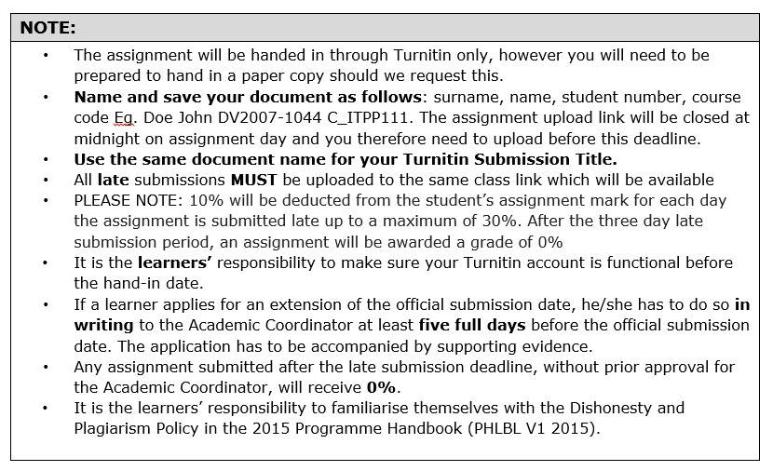

|  |  |  |  |
| --- | --- | --- | --- |
| **Qualification:** | Faculty of Information Technology  Bachelor of Science in Information Technology | | |
| **Module code:** | ITEC301 | **Module name:** | Internet Programming and E-commerce |
| **Assignment title:** | E-commerce Website - Deliverable 2 | | |
| **Date:** | 02 September 2018 | **Submission date:** | 10 September 2018 |
| **Student Name:** | Dreyer Morkel | | |
| **Student Number:** | DV2011-0590 | | |

TABLE OF CONTENTS

SYSTEM DESIGN 3

VISUAL DESIGN 3

USE CASE DIAGRAMS 3

CONTEXT DIAGRAM 7 DATA FLOW DIAGRAMS 8

DATABASE DESIGN 13 CONCEPTUAL DESIGN 13 LOGICAL DESIGN 14 PHYSICAL DESIGN 15

SYSTEM DEVELOPMENT 16 SCREENSHOTS 16

ABOUT US 16

CART 17

COLLECTION 18

CONTACT US 19

CONTENT MANAGEMENT 20

HOME 21

INSERT COLLECTION 22

INSERT PRODUCT 22

LOGIN 23

PRODUCT 24

SHOP 25

UPDATE COLLECTION 26

UPDATE PRODUCT 27

VIEW REPORT 28

SAMPLE CODE 28

SAMPLE SQL 29

SAMPLE PHP 39

SAMPLE HTML/JAVASCRIPT/CSS 61

BIBLIOGRAPHY 92

1. SYSTEM DESIGN
   1. VISUAL DESIGN
      1. USE CASE DIAGRAMS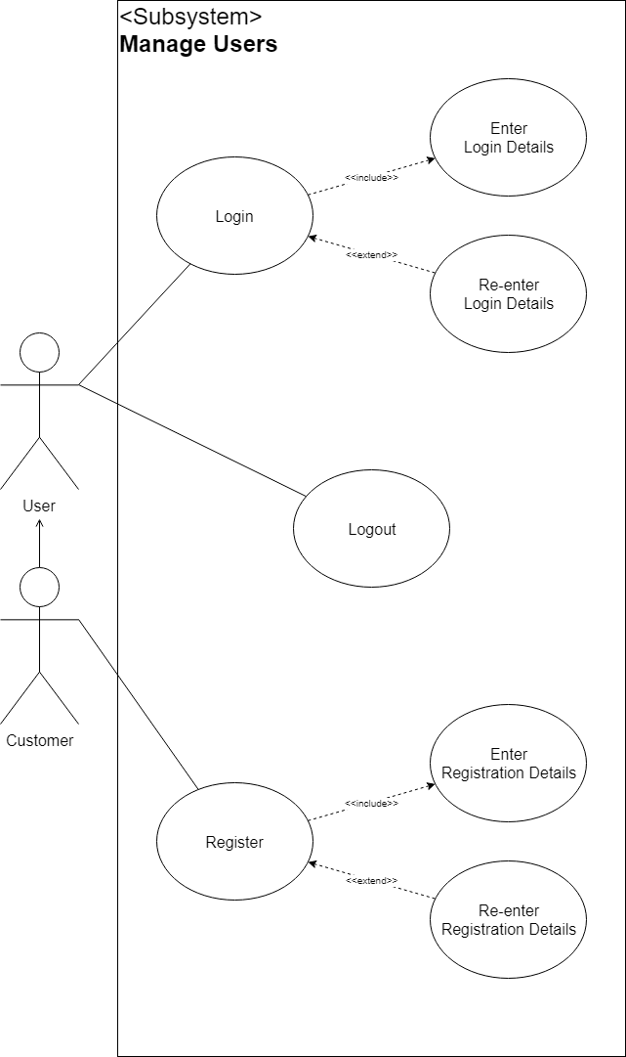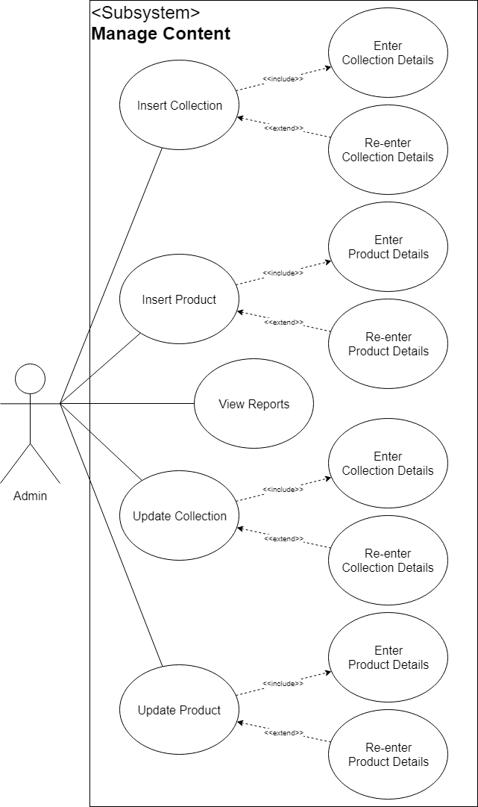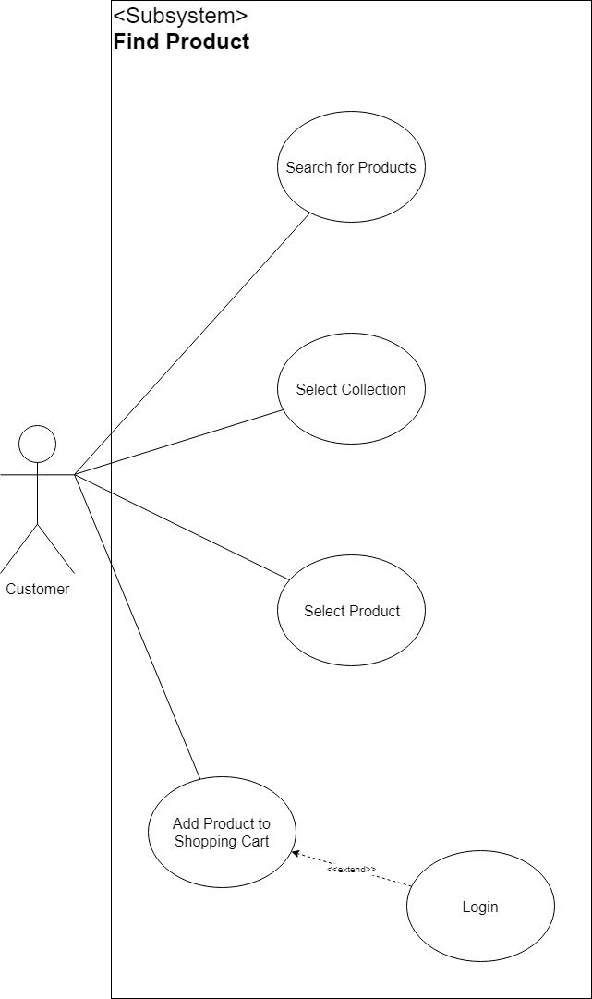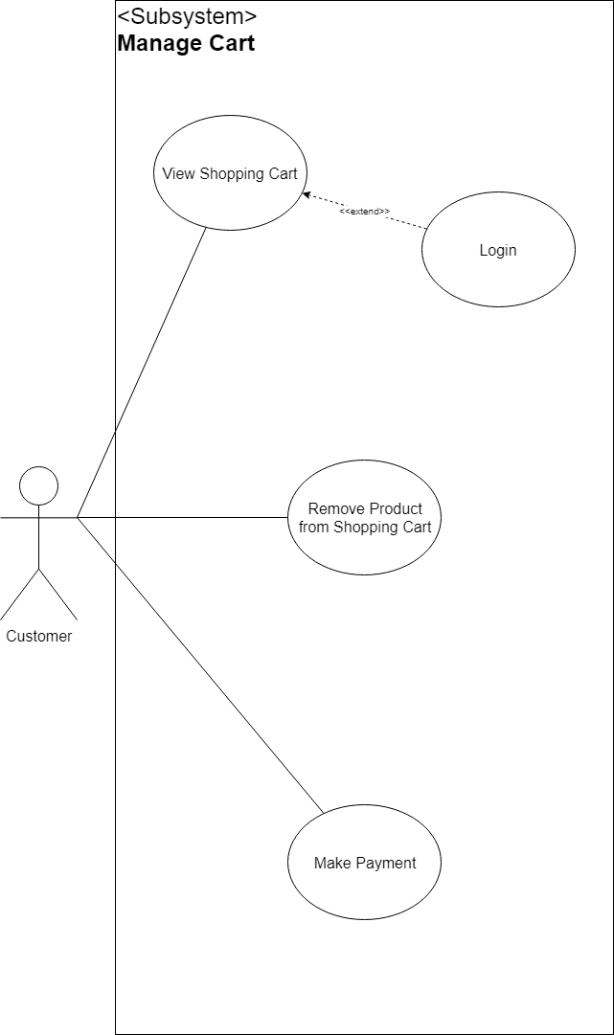
      2. CONTEXT DIAGRAM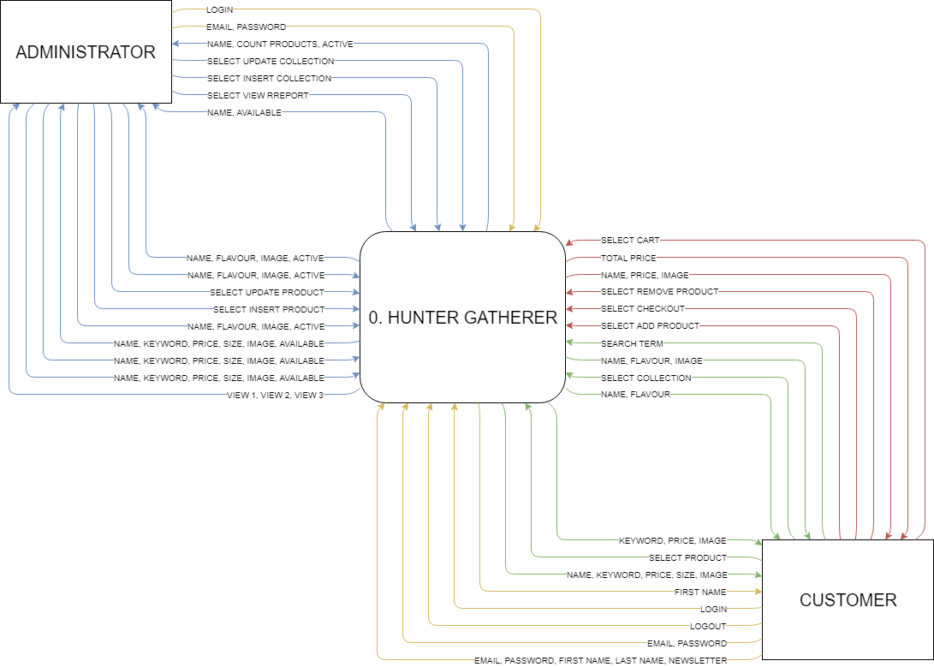
      3. DATA FLOW DIAGRAMS
2. HUNTER GATHERER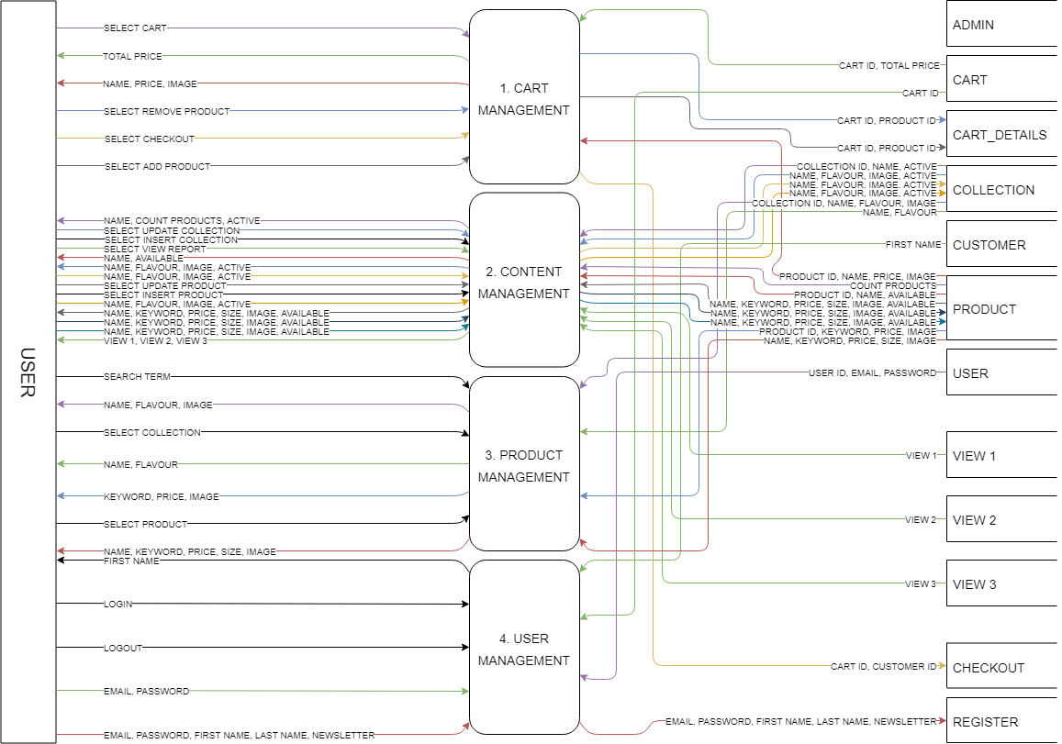
3. CART MANAGEMENT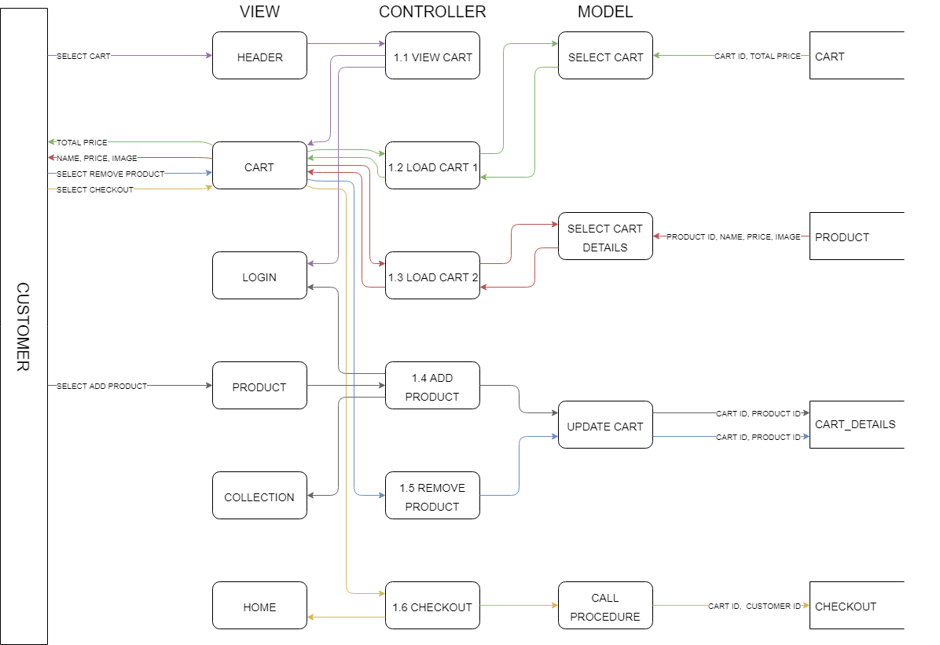
4. CONTENT MANAGEMENT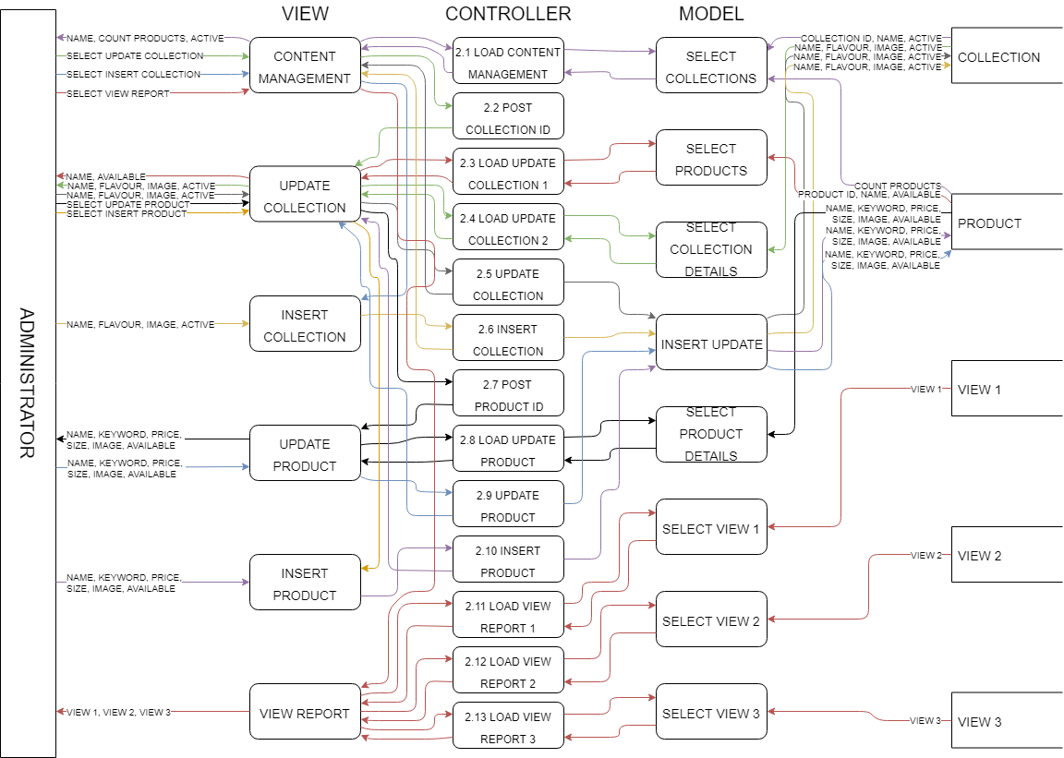
5. PRODUCT MANAGEMENT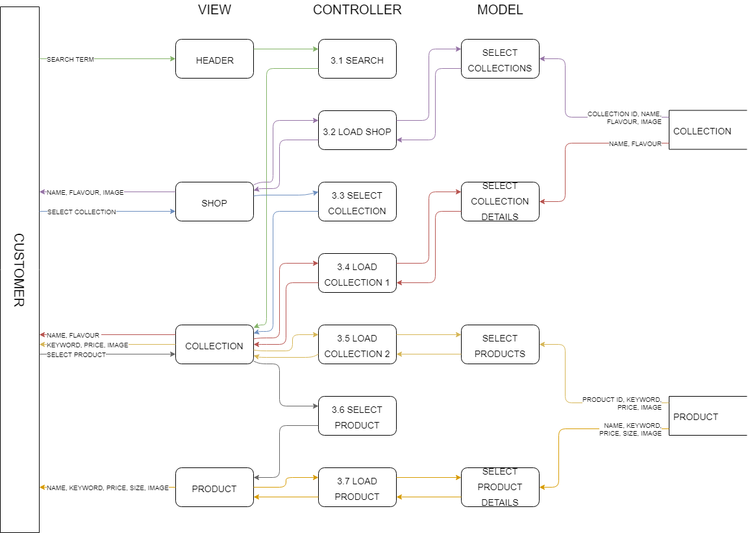
6. USER MANAGEMENT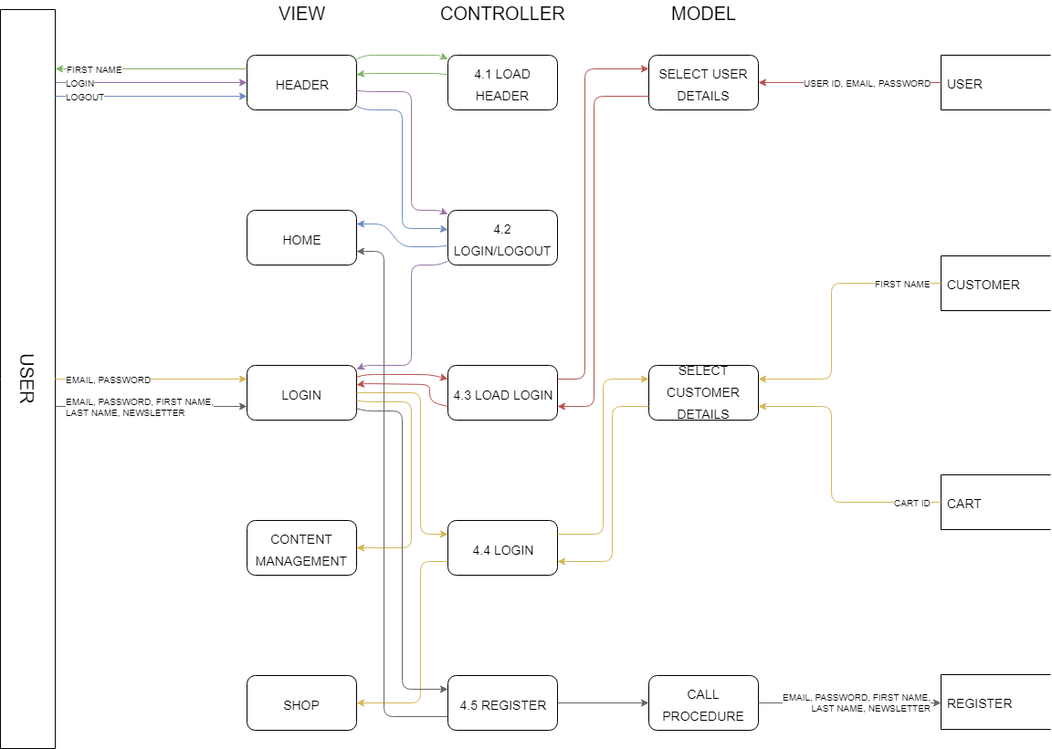
   1. DATABASE DESIGN
      1. CONCEPTUAL DESIGN

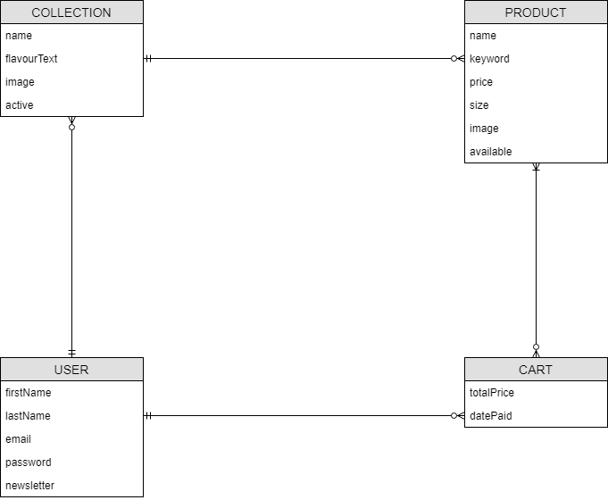

* + 1. LOGICAL DESIGN

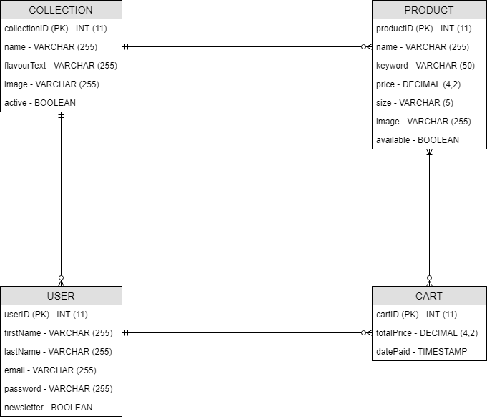

* + 1. PHYSICAL DESIGN

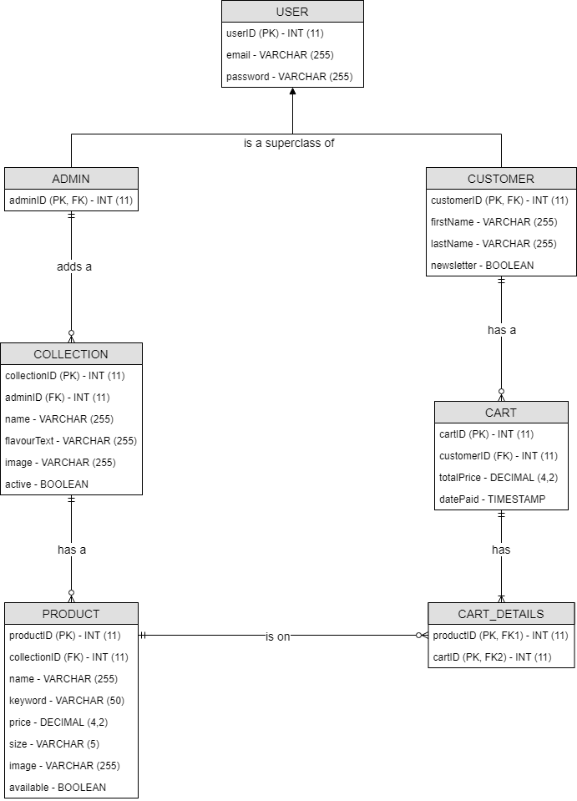

1. SYSTEM DEVELOPMENT
   1. SCREENSHOTS
      1. ABOUT US

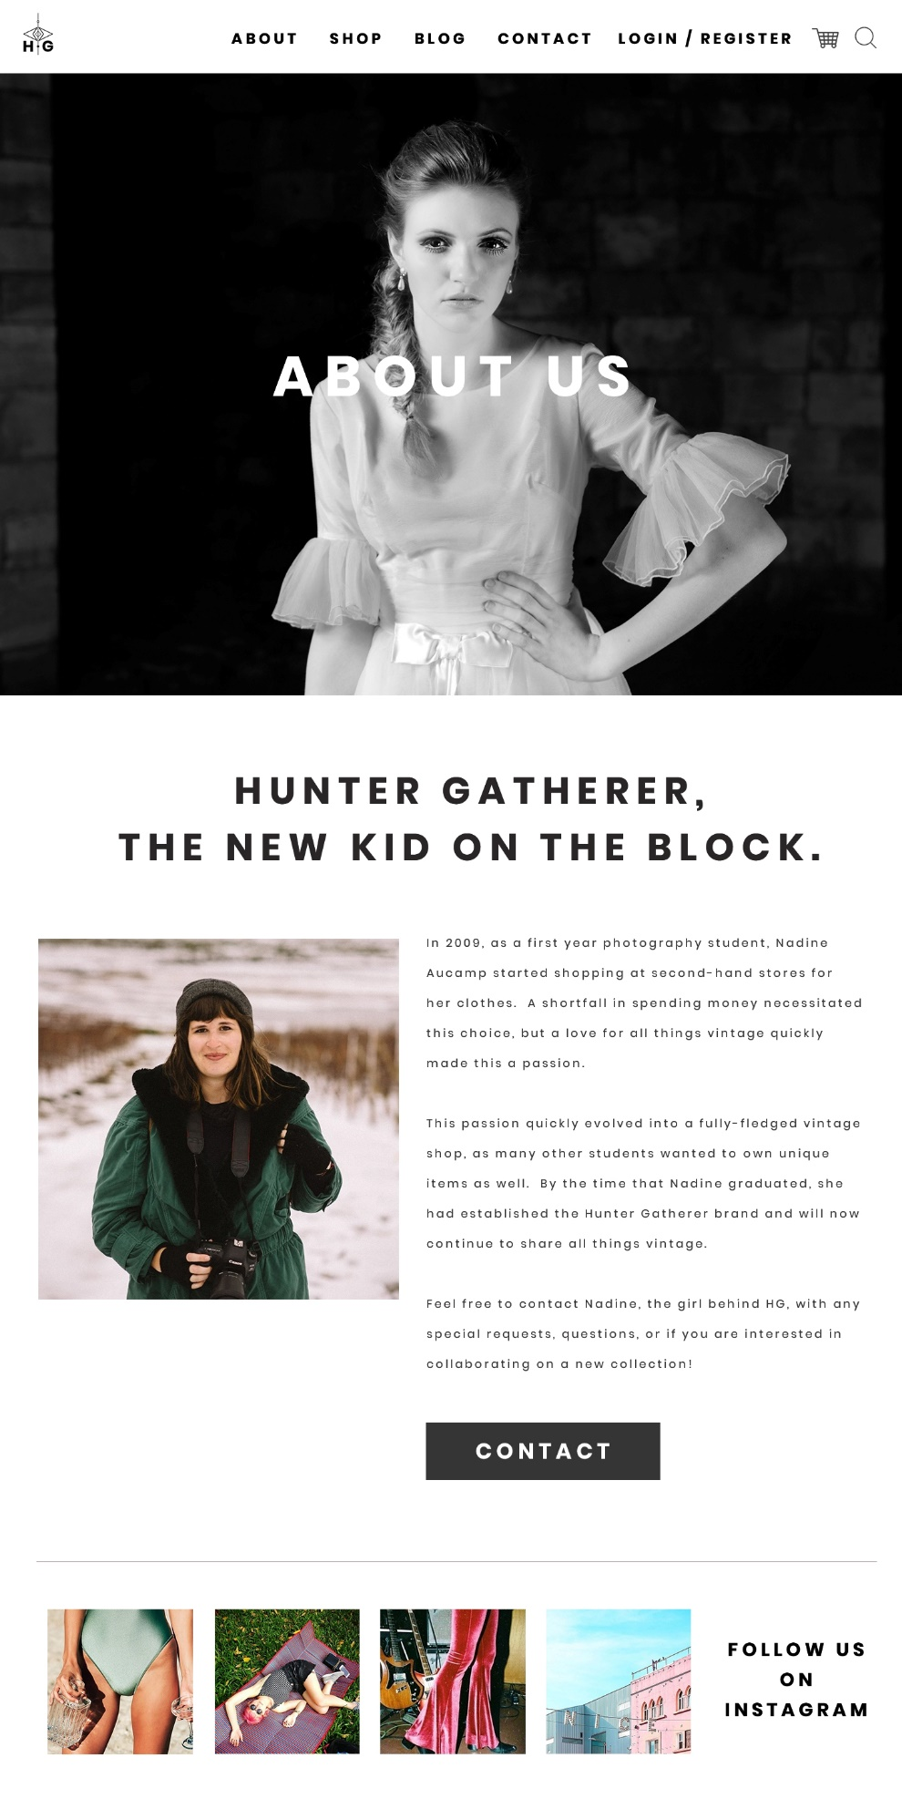

* + 1. CART

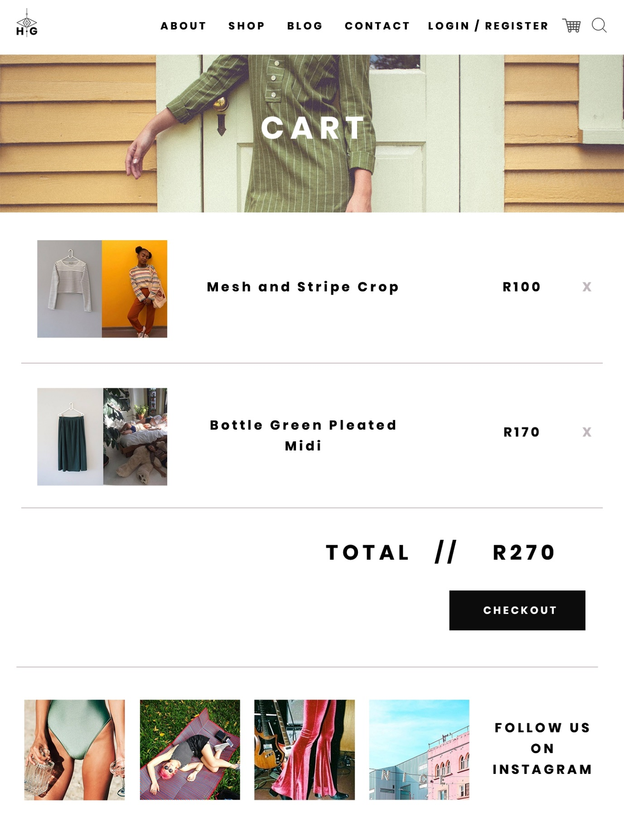

* + 1. COLLECTION

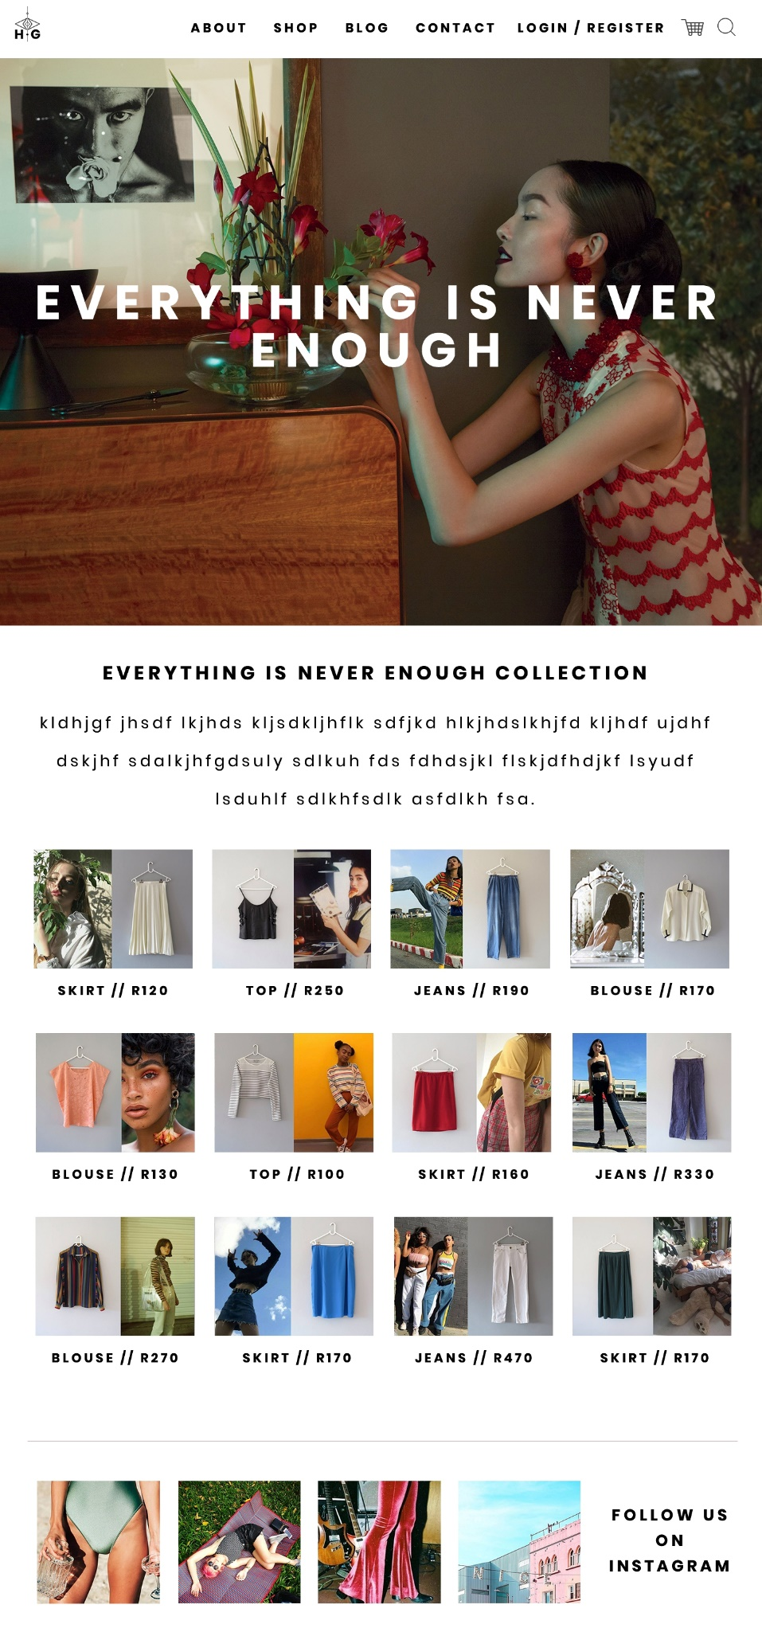

* + 1. CONTACT US

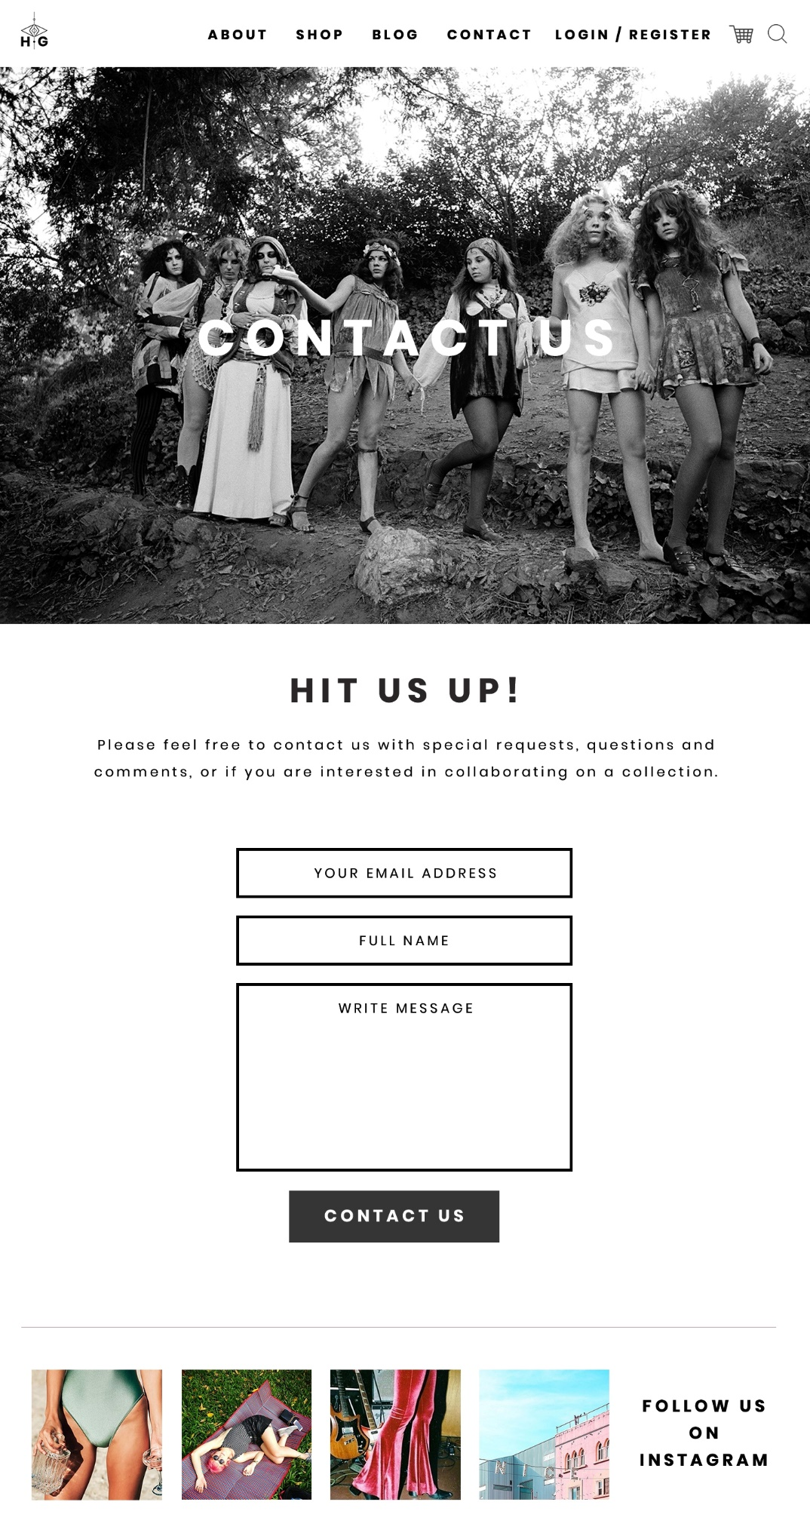

* + 1. CONTENT MANAGEMENT

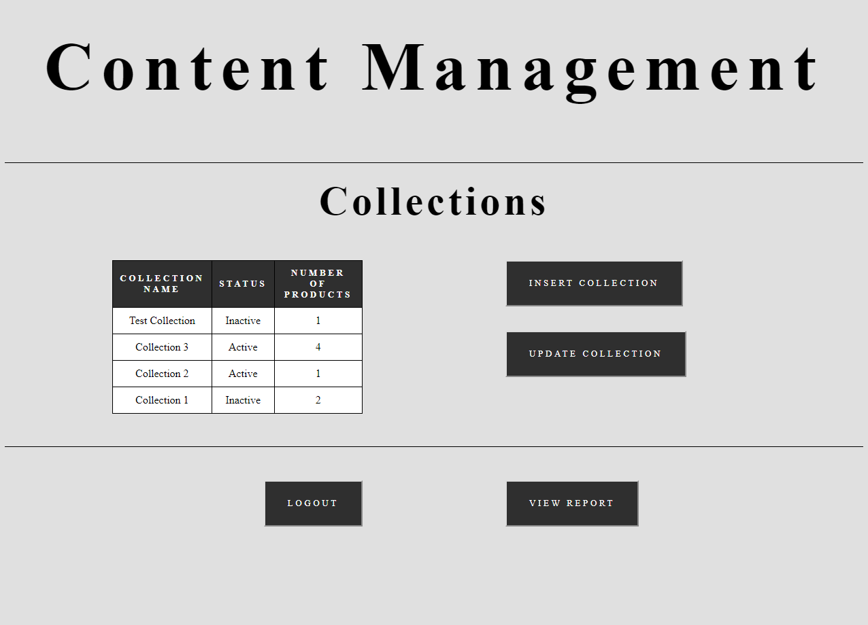

* + 1. HOME



* + 1. INSERT COLLECTION

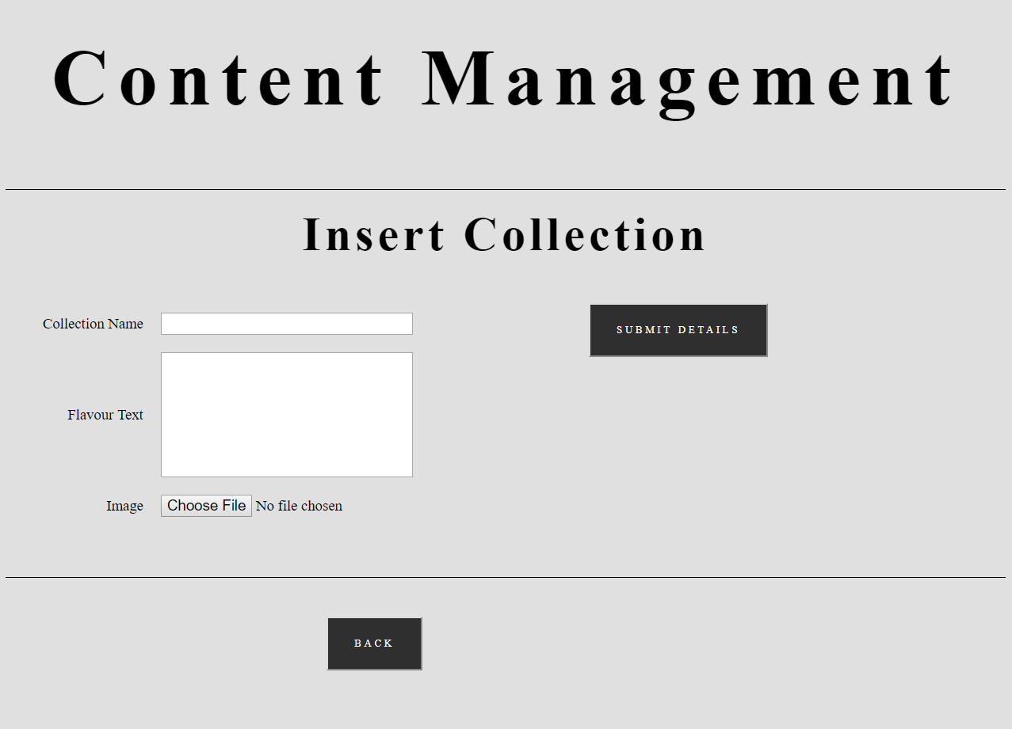

* + 1. INSERT PRODUCT

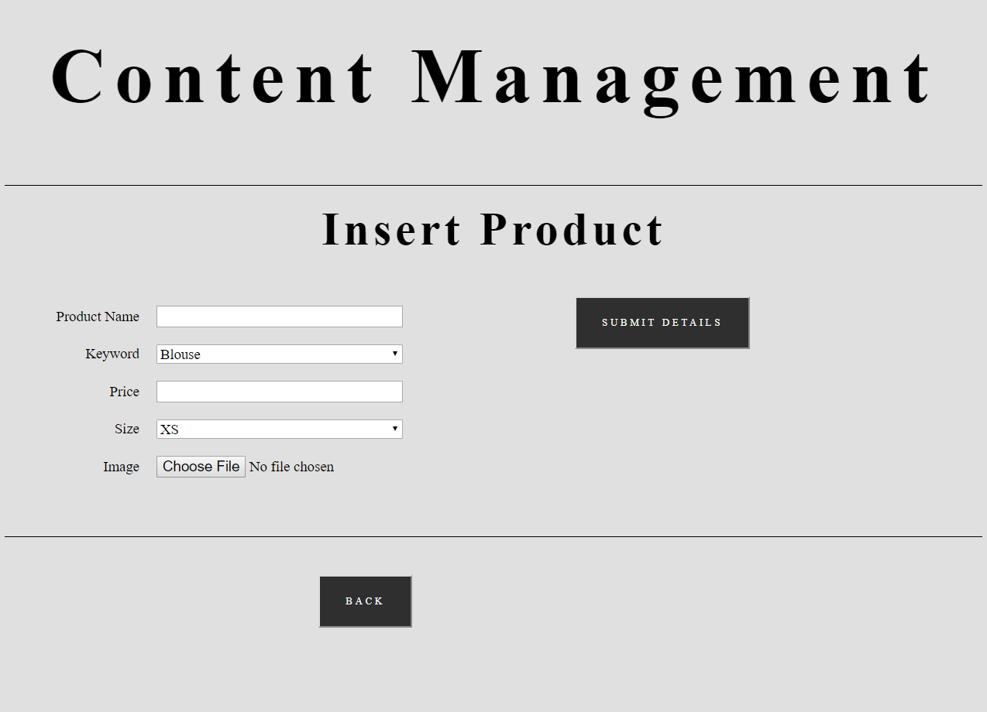

* + 1. LOGIN

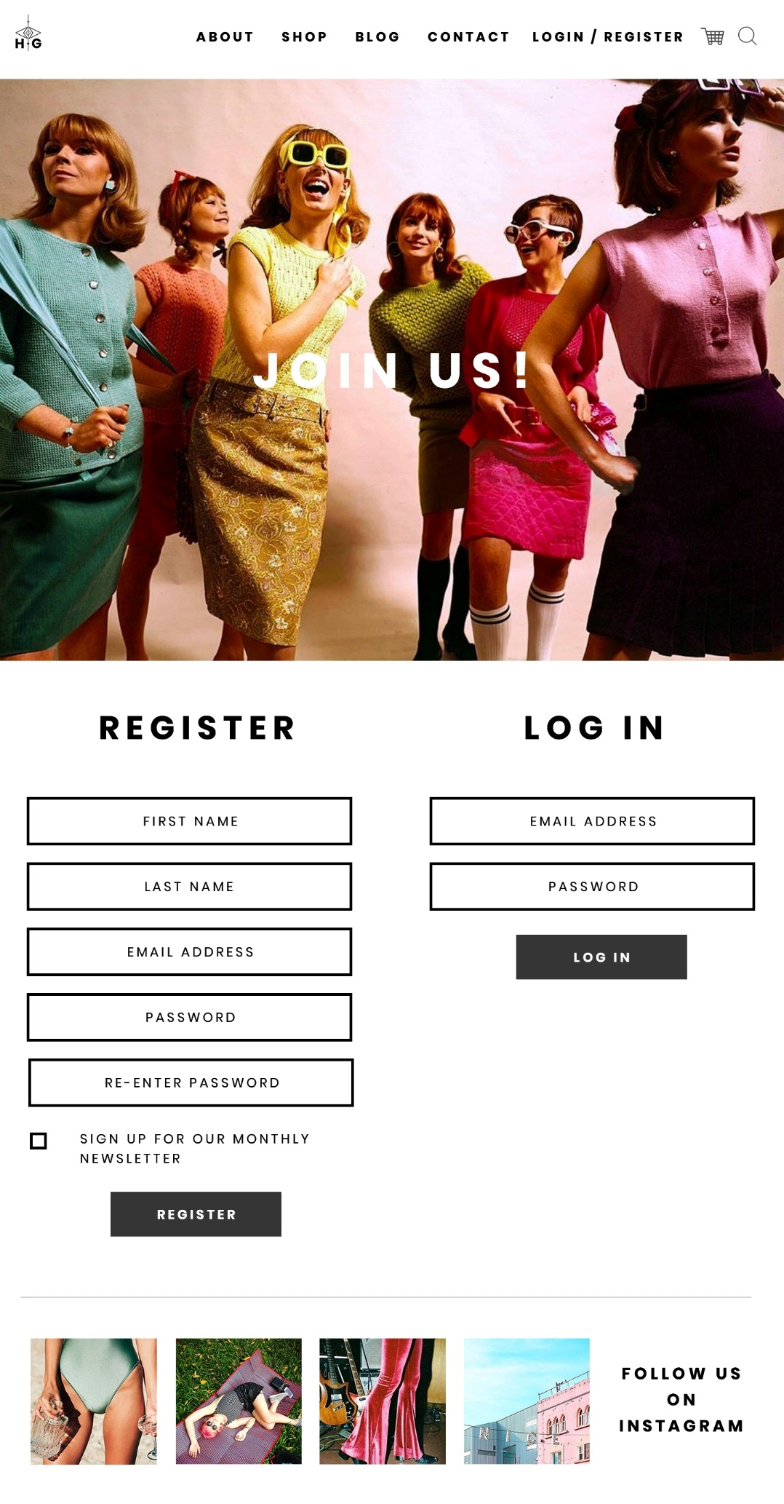

* + 1. PRODUCT

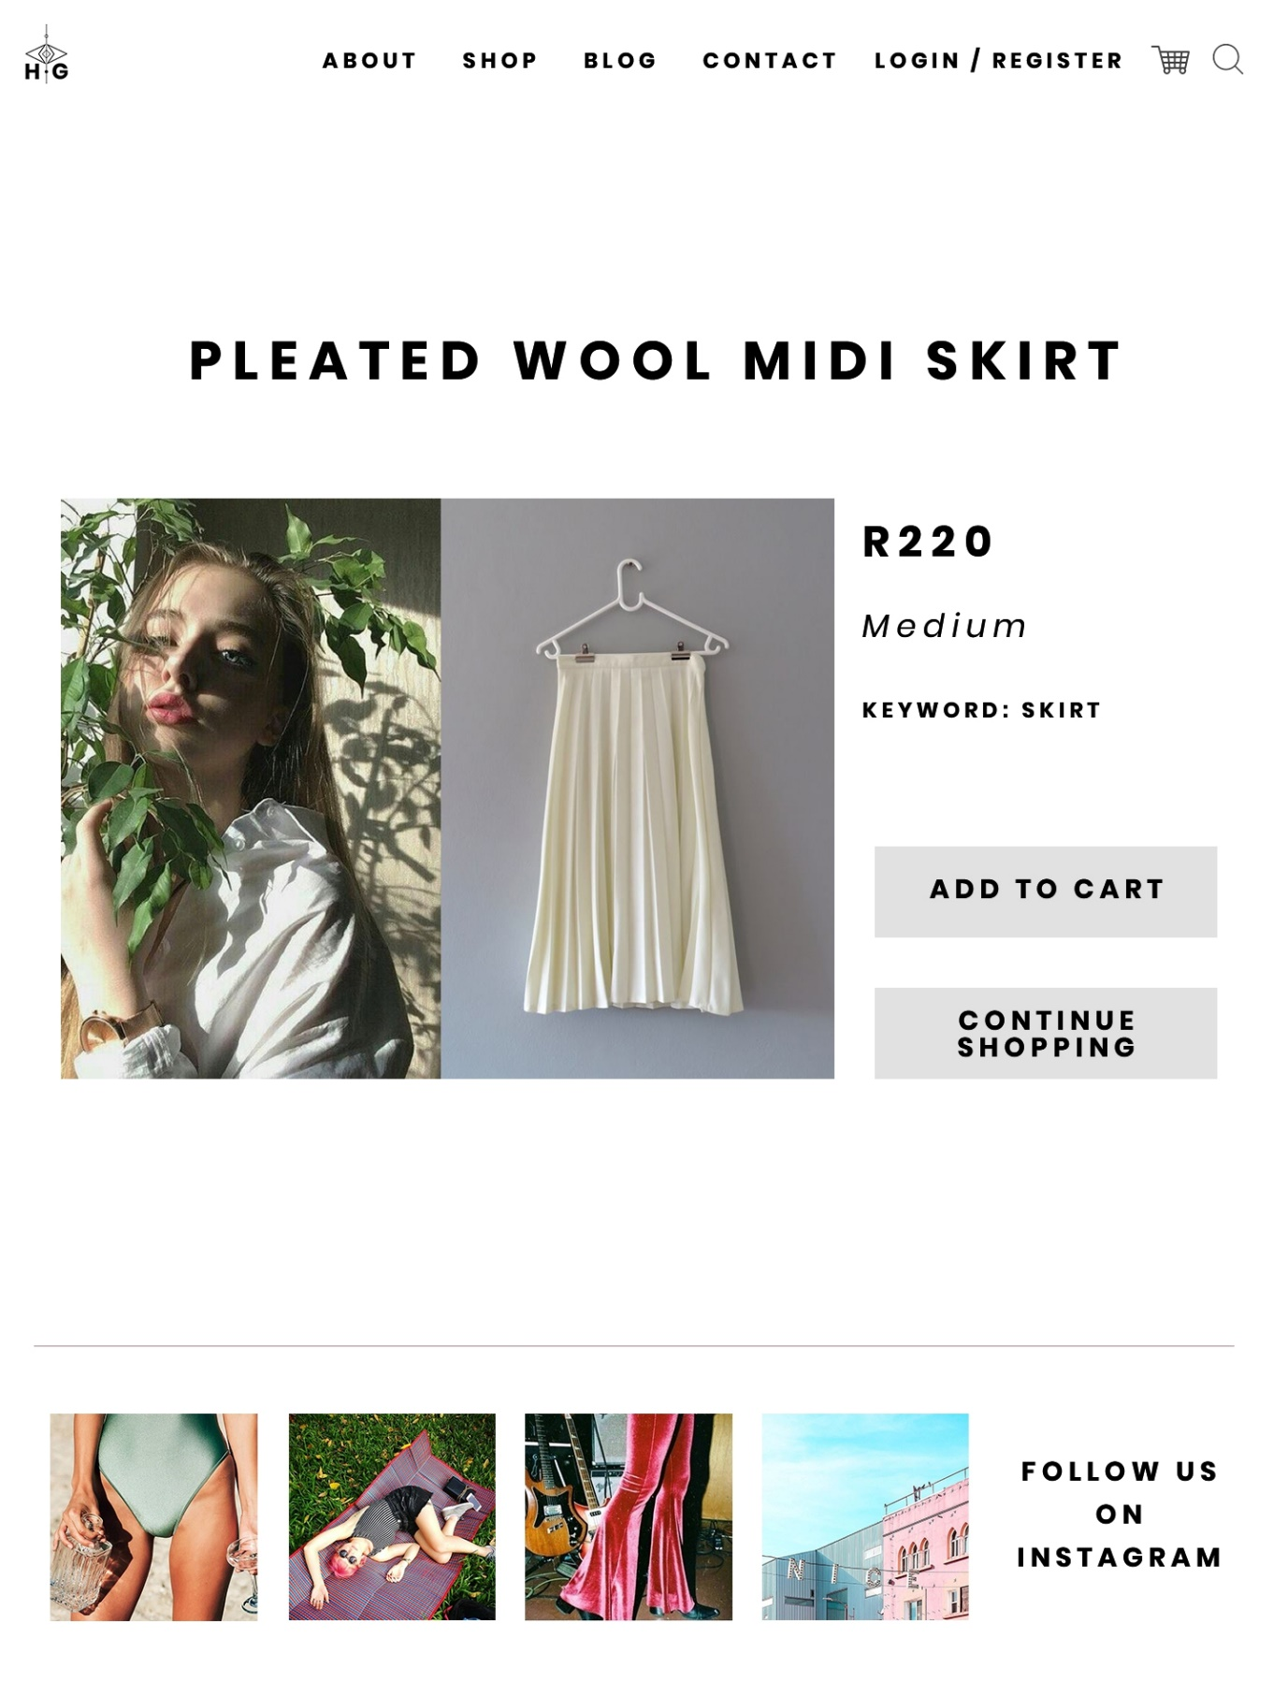

* + 1. SHOP

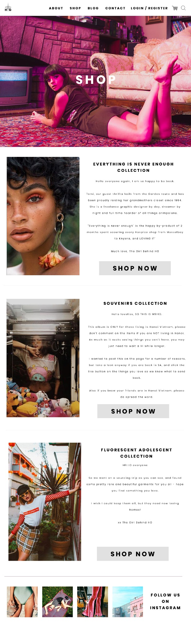

* + 1. UPDATE COLLECTION

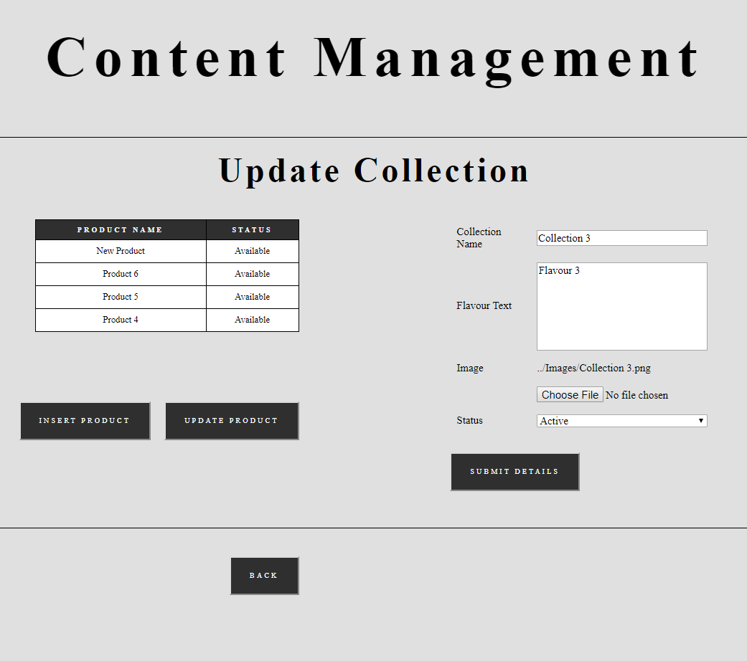

* + 1. UPDATE PRODUCT

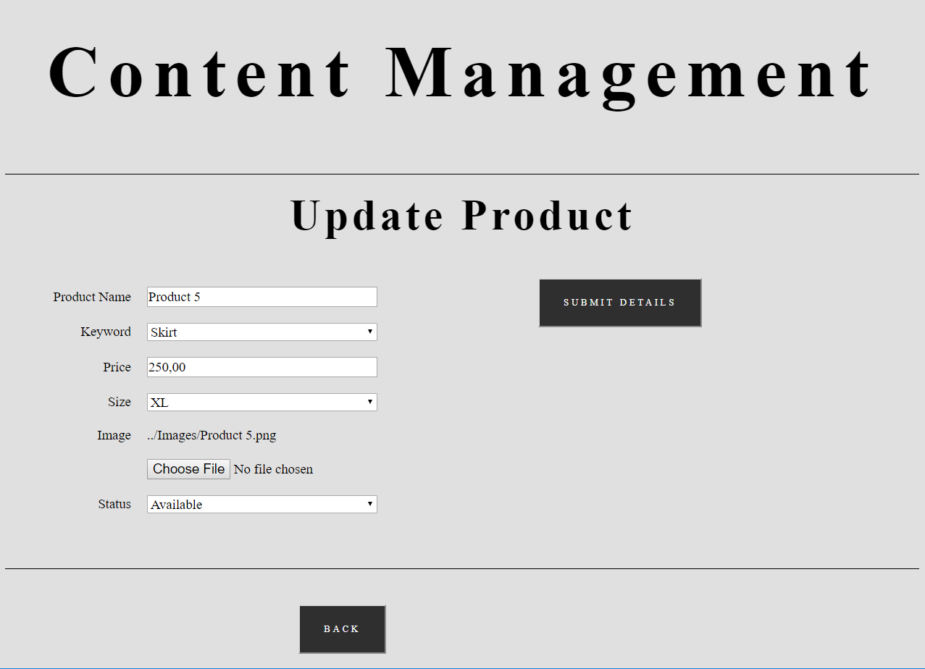

* + 1. VIEW REPORT

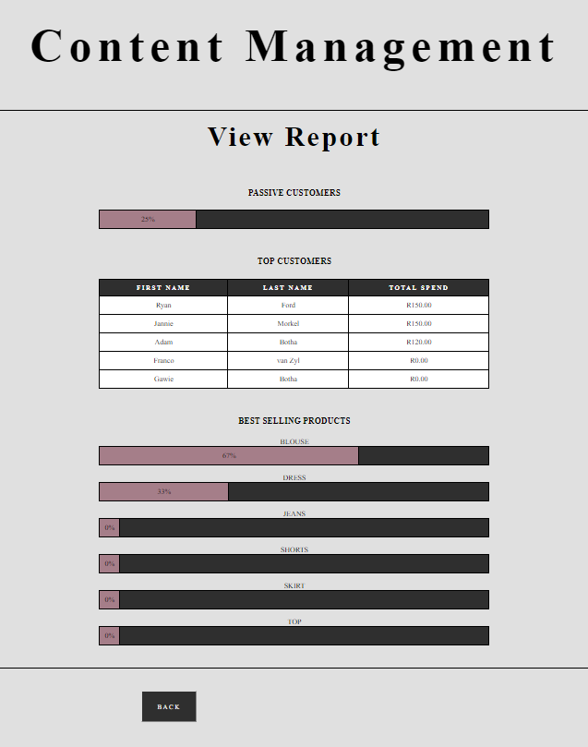

* 1. SAMPLE CODE
     1. SAMPLE SQL

hunter_gatherer_db.sql:

CREATE DATABASE hunter_gatherer_db;

DELIMITER $$

--

-- Procedures

--

CREATE DEFINER=`root`@`localhost` PROCEDURE `calcTotalPrice` () BEGIN

CREATE TEMPORARY TABLE tmp

AS

SELECT SUM(product.price) AS totalP, cart.cartID

FROM cart

LEFT JOIN cart_details ON cart.cartID = cart_details.cartID

LEFT JOIN product ON cart_details.productID = product.productID

GROUP BY cart.cartID;

UPDATE tmp

SET tmp.totalP = IFNULL(tmp.totalP, 0);

UPDATE cart

INNER JOIN tmp

ON cart.cartID = tmp.cartID

SET cart.totalPrice = tmp.totalP

WHERE cart.datePaid IS NULL;

DROP TEMPORARY TABLE IF EXISTS tmp;

END$$

CREATE DEFINER=`root`@`localhost` PROCEDURE `checkout` (IN `outCartID` INT(11), IN `outCustomerID` INT(11)) BEGIN

DECLARE newCartID INT(11);

UPDATE cart

SET cart.datePaid = NOW()

WHERE cart.cartID = outCartID;

DELETE t1.*

FROM cart_details t1

INNER JOIN (

SELECT cart_details.productID

FROM cart_details

GROUP BY cart_details.productID

HAVING COUNT(*)>1) t2

ON t1.productID = t2.productID

AND t1.cartID <> outCartID;

INSERT INTO cart (cart.customerID)

VALUES (outCustomerID);

SELECT cart.cartID

INTO newCartID

FROM cart

WHERE cart.customerID = outCustomerID

AND cart.datePaid IS NULL;

SELECT newCartID;

END$$

CREATE DEFINER=`root`@`localhost` PROCEDURE `register` (IN `regEmail` VARCHAR(255), IN `regPassword` VARCHAR(255), IN `regFirstName` VARCHAR(255), IN `regLastName` VARCHAR(255), IN `regNewsletter` TINYINT(1)) BEGIN

DECLARE regID INT(11);

INSERT INTO user (

user.email,

user.password

)

VALUES (

regEmail,

regPassword

);

SELECT user.userID INTO regID FROM user WHERE user.email = regEmail;

INSERT INTO customer (

customer.customerID,

customer.firstName,

customer.lastName,

customer.newsletter

)

VALUES (

regID,

regFirstName,

regLastName,

regNewsletter

);

INSERT INTO cart (

cart.customerID

)

VALUES (

regID

);

END$$

DELIMITER ;

--

-- Table structure for table `admin`

--

CREATE TABLE `admin` (

`adminID` int(11) NOT NULL

) ENGINE=InnoDB DEFAULT CHARSET=latin1;

-- --------------------------------------------------------

--

-- Table structure for table `cart`

--

CREATE TABLE `cart` (

`cartID` int(11) NOT NULL,

`customerID` int(11) NOT NULL,

`totalPrice` decimal(7,2) NOT NULL DEFAULT '0.00',

`datePaid` timestamp NULL DEFAULT NULL

) ENGINE=InnoDB DEFAULT CHARSET=latin1;

--

-- Triggers `cart`

--

DELIMITER $$

CREATE TRIGGER `availability` AFTER UPDATE ON `cart` FOR EACH ROW BEGIN

IF NEW.datePaid IS NOT NULL THEN

UPDATE product

LEFT JOIN cart_details

ON product.productID = cart_details.productID

LEFT JOIN cart

ON cart_details.cartID = cart.cartID

SET product.available = 0

WHERE cart.datePaid IS NOT NULL;

UPDATE collection

LEFT JOIN

(SELECT product.collectionID, SUM(product.available) AS tot

FROM product

GROUP BY product.collectionID

) tmp

ON collection.collectionID = tmp.collectionID

SET collection.active = 0

WHERE tot = 0;

END IF;

END

$$

DELIMITER ;

-- --------------------------------------------------------

--

-- Table structure for table `cart_details`

--

CREATE TABLE `cart_details` (

`productID` int(11) NOT NULL,

`cartID` int(11) NOT NULL

) ENGINE=InnoDB DEFAULT CHARSET=latin1;

--

-- Triggers `cart_details`

--

DELIMITER $$

CREATE TRIGGER `calcTotalPriceDelete` AFTER DELETE ON `cart_details` FOR EACH ROW BEGIN

CALL calcTotalPrice;

END

$$

DELIMITER ;

DELIMITER $$

CREATE TRIGGER `calcTotalPriceInsert` AFTER INSERT ON `cart_details` FOR EACH ROW BEGIN

CALL calcTotalPrice;

END

$$

DELIMITER ;

-- --------------------------------------------------------

--

-- Table structure for table `collection`

--

CREATE TABLE `collection` (

`collectionID` int(11) NOT NULL,

`adminID` int(11) NOT NULL,

`name` varchar(255) NOT NULL,

`flavourText` varchar(255) NOT NULL,

`image` varchar(255) NOT NULL,

`active` tinyint(1) NOT NULL

) ENGINE=InnoDB DEFAULT CHARSET=latin1;

-- --------------------------------------------------------

--

-- Table structure for table `customer`

--

CREATE TABLE `customer` (

`customerID` int(11) NOT NULL,

`firstName` varchar(255) NOT NULL,

`lastName` varchar(255) NOT NULL,

`newsletter` tinyint(1) NOT NULL

) ENGINE=InnoDB DEFAULT CHARSET=latin1;

-- --------------------------------------------------------

--

-- Table structure for table `product`

--

CREATE TABLE `product` (

`productID` int(11) NOT NULL,

`collectionID` int(11) NOT NULL,

`name` varchar(255) NOT NULL,

`keyword` enum('Blouse','Dress','Jeans','Shorts','Skirt','Top') NOT NULL,

`price` decimal(6,2) NOT NULL,

`size` enum('XS','S','M','L','XL') NOT NULL,

`image` varchar(255) NOT NULL,

`available` tinyint(1) NOT NULL

) ENGINE=InnoDB DEFAULT CHARSET=latin1;

-- --------------------------------------------------------

--

-- Stand-in structure for view `subview1`

-- (See below for the actual view)

--

CREATE TABLE `subview1` (

`customerID` int(11)

);

-- --------------------------------------------------------

--

-- Stand-in structure for view `subview2`

-- (See below for the actual view)

--

CREATE TABLE `subview2` (

`passiveCustomers` bigint(21)

);

-- --------------------------------------------------------

--

-- Table structure for table `user`

--

CREATE TABLE `user` (

`userID` int(11) NOT NULL,

`email` varchar(255) NOT NULL,

`password` varchar(255) NOT NULL

) ENGINE=InnoDB DEFAULT CHARSET=latin1;

-- --------------------------------------------------------

--

-- Stand-in structure for view `view1`

-- (See below for the actual view)

--

CREATE TABLE `view1` (

`passiveCustomers` bigint(21)

,`totalCustomers` bigint(21)

);

-- --------------------------------------------------------

--

-- Stand-in structure for view `view2`

-- (See below for the actual view)

--

CREATE TABLE `view2` (

`firstName` varchar(255)

,`lastName` varchar(255)

,`totalSpend` decimal(29,2)

);

-- --------------------------------------------------------

--

-- Stand-in structure for view `view3`

-- (See below for the actual view)

--

CREATE TABLE `view3` (

`keyword` enum('Blouse','Dress','Jeans','Shorts','Skirt','Top')

,`totalSales` bigint(21)

);

-- --------------------------------------------------------

--

-- Structure for view `subview1`

--

DROP TABLE IF EXISTS `subview1`;

CREATE ALGORITHM=UNDEFINED DEFINER=`root`@`localhost` SQL SECURITY DEFINER VIEW `subview1` AS select `cart`.`customerID` AS `customerID` from `cart` group by `cart`.`customerID` having (count(`cart`.`customerID`) > 1) ;

-- --------------------------------------------------------

--

-- Structure for view `subview2`

--

DROP TABLE IF EXISTS `subview2`;

CREATE ALGORITHM=UNDEFINED DEFINER=`root`@`localhost` SQL SECURITY DEFINER VIEW `subview2` AS select count(0) AS `passiveCustomers` from `subview1` ;

-- --------------------------------------------------------

--

-- Structure for view `view1`

--

DROP TABLE IF EXISTS `view1`;

CREATE ALGORITHM=UNDEFINED DEFINER=`root`@`localhost` SQL SECURITY DEFINER VIEW `view1` AS select `subview2`.`passiveCustomers` AS `passiveCustomers`,count(`customer`.`customerID`) AS `totalCustomers` from (`subview2` join `customer`) ;

-- --------------------------------------------------------

--

-- Structure for view `view2`

--

DROP TABLE IF EXISTS `view2`;

CREATE ALGORITHM=UNDEFINED DEFINER=`root`@`localhost` SQL SECURITY DEFINER VIEW `view2` AS select `customer`.`firstName` AS `firstName`,`customer`.`lastName` AS `lastName`,sum(`cart`.`totalPrice`) AS `totalSpend` from (`customer` join `cart`) where (`customer`.`customerID` = `cart`.`customerID`) group by `cart`.`customerID` order by sum(`cart`.`totalPrice`) desc limit 5 ;

-- --------------------------------------------------------

--

-- Structure for view `view3`

--

DROP TABLE IF EXISTS `view3`;

CREATE ALGORITHM=UNDEFINED DEFINER=`root`@`localhost` SQL SECURITY DEFINER VIEW `view3` AS select `product`.`keyword` AS `keyword`,ifnull(count(0),0) AS `totalSales` from `product` where (`product`.`available` = 0) group by `product`.`keyword` ;

--

-- Indexes for dumped tables

--

--

-- Indexes for table `admin`

--

ALTER TABLE `admin`

ADD PRIMARY KEY (`adminID`);

--

-- Indexes for table `cart`

--

ALTER TABLE `cart`

ADD PRIMARY KEY (`cartID`),

ADD KEY `customerID` (`customerID`);

--

-- Indexes for table `cart_details`

--

ALTER TABLE `cart_details`

ADD PRIMARY KEY (`productID`,`cartID`),

ADD KEY `cartID` (`cartID`);

--

-- Indexes for table `collection`

--

ALTER TABLE `collection`

ADD PRIMARY KEY (`collectionID`),

ADD KEY `adminID` (`adminID`);

--

-- Indexes for table `customer`

--

ALTER TABLE `customer`

ADD PRIMARY KEY (`customerID`);

--

-- Indexes for table `product`

--

ALTER TABLE `product`

ADD PRIMARY KEY (`productID`),

ADD KEY `collectionID` (`collectionID`);

--

-- Indexes for table `user`

--

ALTER TABLE `user`

ADD PRIMARY KEY (`userID`);

--

-- AUTO_INCREMENT for dumped tables

--

--

-- AUTO_INCREMENT for table `cart`

--

ALTER TABLE `cart`

MODIFY `cartID` int(11) NOT NULL AUTO_INCREMENT, AUTO_INCREMENT=25;

--

-- AUTO_INCREMENT for table `collection`

--

ALTER TABLE `collection`

MODIFY `collectionID` int(11) NOT NULL AUTO_INCREMENT, AUTO_INCREMENT=10;

--

-- AUTO_INCREMENT for table `product`

--

ALTER TABLE `product`

MODIFY `productID` int(11) NOT NULL AUTO_INCREMENT, AUTO_INCREMENT=9;

--

-- AUTO_INCREMENT for table `user`

--

ALTER TABLE `user`

MODIFY `userID` int(11) NOT NULL AUTO_INCREMENT, AUTO_INCREMENT=13;

--

-- Constraints for dumped tables

--

--

-- Constraints for table `admin`

--

ALTER TABLE `admin`

ADD CONSTRAINT `admin_ibfk_1` FOREIGN KEY (`adminID`) REFERENCES `user` (`userID`);

--

-- Constraints for table `cart`

--

ALTER TABLE `cart`

ADD CONSTRAINT `cart_ibfk_1` FOREIGN KEY (`customerID`) REFERENCES `customer` (`customerID`);

--

-- Constraints for table `cart_details`

--

ALTER TABLE `cart_details`

ADD CONSTRAINT `cart_details_ibfk_1` FOREIGN KEY (`productID`) REFERENCES `product` (`productID`),

ADD CONSTRAINT `cart_details_ibfk_2` FOREIGN KEY (`cartID`) REFERENCES `cart` (`cartID`);

--

-- Constraints for table `collection`

--

ALTER TABLE `collection`

ADD CONSTRAINT `collection_ibfk_1` FOREIGN KEY (`adminID`) REFERENCES `admin` (`adminID`);

--

-- Constraints for table `customer`

--

ALTER TABLE `customer`

ADD CONSTRAINT `customer_ibfk_1` FOREIGN KEY (`customerID`) REFERENCES `user` (`userID`);

--

-- Constraints for table `product`

--

ALTER TABLE `product`

ADD CONSTRAINT `product_ibfk_1` FOREIGN KEY (`collectionID`) REFERENCES `collection` (`collectionID`);

COMMIT;

* + 1. SAMPLE PHP

**Models/cartManagement.php:**

<?php

//CART VIEW

function selectCart($sql) {

$data = array();

$conn = new mysqli("localhost", "root", "", "hunter_gatherer_db");

$result = $conn->query($sql);

if ($result->num_rows > 0) {

while ($row = $result->fetch_assoc()) {

$data[0] = $row["cartID"];

$data[1] = $row["totalPrice"];

}

}

$conn->close();

return $data;

}

function selectCartDetails($sql) {

$data = array();

$conn = new mysqli("localhost", "root", "", "hunter_gatherer_db");

$result = $conn->query($sql);

if ($result->num_rows > 0) {

$i = 0;

while ($row = $result->fetch_assoc()) {

$data[$i][0] = $row["productID"];

$data[$i][1] = $row["name"];

$data[$i][2] =$row["price"];

$data[$i][3] =$row["image"];

$i++;

}

}

$conn->close();

return $data;

}

function callProcedure($sql) {

$conn = new mysqli("localhost", "root", "", "hunter_gatherer_db");

$result = $conn->query($sql);

if ($result->num_rows > 0) {

while ($row = $result->fetch_assoc()) {

$data = $row["newCartID"];

}

}

$conn->close();

return $data;

}

//MISCELLANEOUS

function updateCart($sql) {

$conn = new mysqli("localhost", "root", "", "hunter_gatherer_db");

$conn->query($sql);

$conn->close();

}

?>

**Models/contentManagement.php:**

<?php

//CONTENT MANAGEMENT VIEW

function selectCollections($sql) {

$data = array();

$conn = new mysqli("localhost", "root", "", "hunter_gatherer_db");

$result = $conn->query($sql);

if ($result->num_rows > 0) {

$i = 0;

while ($row = $result->fetch_assoc()) {

$data[$i][0] = $row["collectionID"];

$data[$i][1] = $row["name"];

$data[$i][2] =$row["active"];

$data[$i][3] =$row["numProducts"];

$i++;

}

}

$conn->close();

return $data;

}

//UPDATE COLLECTION VIEW

function selectProducts($sql) {

$data = array();

$conn = new mysqli("localhost", "root", "", "hunter_gatherer_db");

$result = $conn->query($sql);

if ($result->num_rows > 0) {

$i = 0;

while ($row = $result->fetch_assoc()) {

$data[$i][0] = $row["productID"];

$data[$i][1] = $row["name"];

$data[$i][2] =$row["available"];

$i++;

}

}

$conn->close();

return $data;

}

function selectCollectionDetails($sql) {

$data = array();

$conn = new mysqli("localhost", "root", "", "hunter_gatherer_db");

$result = $conn->query($sql);

if ($result->num_rows > 0) {

while ($row = $result->fetch_assoc()) {

$data[0] = $row["name"];

$data[1] = $row["flavourText"];

$data[2] =$row["image"];

$data[3] =$row["active"];

}

}

$conn->close();

return $data;

}

//UPDATE PRODUCT VIEW

function selectProductDetails($sql) {

$data = array();

$conn = new mysqli("localhost", "root", "", "hunter_gatherer_db");

$result = $conn->query($sql);

if ($result->num_rows > 0) {

while ($row = $result->fetch_assoc()) {

$data[0] = $row["name"];

$data[1] = $row["keyword"];

$data[2] =$row["price"];

$data[3] =$row["size"];

$data[4] =$row["image"];

$data[5] =$row["available"];

}

}

$conn->close();

return $data;

}

//VIEW REPORT VIEW

function selectView1($sql) {

$data = array();

$conn = new mysqli("localhost", "root", "", "hunter_gatherer_db");

$result = $conn->query($sql);

if ($result->num_rows > 0) {

while ($row = $result->fetch_assoc()) {

$data[0] = $row["passiveCustomers"];

$data[1] = $row["totalCustomers"];

}

}

$conn->close();

return $data;

}

function selectView2($sql) {

$data = array();

$conn = new mysqli("localhost", "root", "", "hunter_gatherer_db");

$result = $conn->query($sql);

if ($result->num_rows > 0) {

$i = 0;

while ($row = $result->fetch_assoc()) {

$data[$i][0] = $row["firstName"];

$data[$i][1] = $row["lastName"];

$data[$i][2] = $row["totalSpend"];

$i++;

}

}

$conn->close();

return $data;

}

function selectView3($sql) {

$data = array();

$conn = new mysqli("localhost", "root", "", "hunter_gatherer_db");

$result = $conn->query($sql);

if ($result->num_rows > 0) {

$i = 0;

while ($row = $result->fetch_assoc()) {

$data[$i][0] = $row["keyword"];

$data[$i][1] = $row["totalSales"];

$i++;

}

}

$conn->close();

return $data;

}

//MISCELLANEOUS

function insertUpdate($sql) {

$conn = new mysqli("localhost", "root", "", "hunter_gatherer_db");

$conn->query($sql);

$conn->close();

}

?>

**Models/productManagement.php:**

<?php

//SHOP VIEW

function selectCollections($sql) {

$data = array();

$conn = new mysqli("localhost", "root", "", "hunter_gatherer_db");

$result = $conn->query($sql);

if ($result->num_rows > 0) {

$i = 0;

while ($row = $result->fetch_assoc()) {

$data[$i][0] = $row["collectionID"];

$data[$i][1] = $row["name"];

$data[$i][2] =$row["flavourText"];

$data[$i][3] =$row["image"];

$i++;

}

}

$conn->close();

return $data;

}

function selectCollectionDetails($sql) {

$data = array();

$conn = new mysqli("localhost", "root", "", "hunter_gatherer_db");

$result = $conn->query($sql);

if ($result->num_rows > 0) {

while ($row = $result->fetch_assoc()) {

$data[0] = $row["name"];

$data[1] = $row["flavourText"];

}

}

$conn->close();

return $data;

}

//COLLECTION VIEW

function selectProducts($sql) {

$data = array();

$conn = new mysqli("localhost", "root", "", "hunter_gatherer_db");

$result = $conn->query($sql);

if ($result->num_rows > 0) {

$i = 0;

while ($row = $result->fetch_assoc()) {

$data[$i][0] = $row["productID"];

$data[$i][1] = $row["keyword"];

$data[$i][2] =$row["price"];

$data[$i][3] =$row["image"];

$i++;

}

}

$conn->close();

return $data;

}

//PRODUCT VIEW

function selectProductDetails($sql) {

$data = array();

$conn = new mysqli("localhost", "root", "", "hunter_gatherer_db");

$result = $conn->query($sql);

if ($result->num_rows > 0) {

while ($row = $result->fetch_assoc()) {

$data[0] = $row["name"];

$data[1] = $row["keyword"];

$data[2] = $row["price"];

$data[3] = $row["size"];

$data[4] = $row["image"];

}

}

$conn->close();

return $data;

}

?>

**Models/userManagement.php:**

<?php

//LOGIN VIEW

function selectUserDetails($sql) {

$data = array();

$conn = new mysqli("localhost", "root", "", "hunter_gatherer_db");

$result = $conn->query($sql);

if ($result->num_rows > 0) {

$i = 0;

while ($row = $result->fetch_assoc()) {

$data[$i][0] = $row["userID"];

$data[$i][1] = $row["email"];

$data[$i][2] = $row["password"];

$i++;

}

}

$conn->close();

return $data;

}

function selectCustomerDetails($sql) {

$data = array();

$conn = new mysqli("localhost", "root", "", "hunter_gatherer_db");

$result = $conn->query($sql);

if ($result->num_rows > 0) {

while ($row = $result->fetch_assoc()) {

$data[0] = $row["firstName"];

$data[1] = $row["cartID"];

}

}

$conn->close();

return $data;

}

function callProcedure($sql) {

$conn = new mysqli("localhost", "root", "", "hunter_gatherer_db");

$conn->query($sql);

$conn->close();

}

?>

**Controllers/cartManagement.php:**

<?php

header("Content-Type: application/json; charset=UTF-8");

session_start();

//HEADER VIEW

if (isset($_POST["viewCart"])) {

//Check if session is active

if ($_SESSION["login"] == 1) {

//Return to Cart View

header("Location: ../Views/cart.html");

} else {

//Return to Login View

header("Location: ../Views/login.html");

}

}

//PRODUCT VIEW

if (isset($_POST["addProduct"])) {

//Check if session is active

if ($_SESSION["login"] == 1) {

//Send SQL statement to Cart Management Model

$sql = "INSERT INTO cart_details (cart_details.productID, cart_details.cartID) SELECT " . $_SESSION["productID"] . ", " . $_SESSION["cartID"] . " FROM dual WHERE NOT EXISTS (SELECT 1 FROM cart_details WHERE cart_details.productID = " . $_SESSION["productID"] . " AND cart_details.cartID = " . $_SESSION["cartID"] . ")";

include "../Models/cartManagement.php";

updateCart($sql);

//Return to Cart View

header("Location: ../Views/collection.html");

} else {

//Return to Login View

header("Location: ../Views/login.html");

}

}

//CART VIEW

if ($_GET["x"] == "loadCart1") {

//Send SQL statement to Cart Management Model

$sql = "SELECT cart.cartID, cart.totalPrice FROM cart WHERE cart.customerID = " . $_SESSION["customerID"] . " AND cart.datePaid IS NULL";

//Save database results

include "../Models/cartManagement.php";

$data = array();

$data = selectCart($sql);

//Save cart ID as a session variable

$_SESSION["cartID"] = $data[0];

//Encode results with JSON

echo json_encode($data[1]);

}

if ($_GET["x"] == "loadCart2") {

//Send SQL statement to Cart Management Model

$sql = "SELECT product.productID, product.name, product.price, product.image FROM product, cart_details WHERE cart_details.cartID = " . $_SESSION["cartID"] . " AND cart_details.productID = product.productID";

//Save database results

include "../Models/cartManagement.php";

$data = array();

$data = selectCartDetails($sql);

//Encode results with JSON

echo json_encode($data);

}

if (isset($_POST["removeProduct"])) {

//Send SQL statement to Cart Management Model

$sql = "DELETE FROM cart_details WHERE cart_details.cartID = " . $_SESSION["cartID"] . " AND cart_details.productID = " . $_POST["productID"];

include "../Models/cartManagement.php";

updateCart($sql);

//Return to Cart View

header("Location: ../Views/cart.html");

}

if (isset($_POST["checkout"])) {

//Send SQL statement to Cart Management Model

$sql = "CALL checkout (" . $_SESSION["cartID"] . ", " . $_SESSION["customerID"] . ")";

$data = array();

include "../Models/cartManagement.php";

$data = callProcedure($sql);

//Save database result as session variable

$_SESSION["cartID"] = $data;

//Return to Home Page View

header("Location: ../index.html");

}

?>

**Controllers/contentManagement.php:**

<?php

header("Content-Type: application/json; charset=UTF-8");

session_start();

//CONTENT MANAGEMENT VIEW

if ($_GET["x"] == "loadContentManagement") {

//Send SQL statement to Content Management Model

$sql = "SELECT collection.collectionID, collection.name, collection.active, COUNT(product.collectionID) AS numProducts FROM collection LEFT JOIN product ON collection.collectionID = product.collectionID GROUP BY collection.collectionID ORDER BY collection.collectionID DESC";

//Save database results

include "../Models/contentManagement.php";

$data = array();

$data = selectCollections($sql);

//Encode results with JSON

echo json_encode($data);

}

if (isset($_POST["postCollectionID"])) {

//Save collection ID as session variable

$_SESSION["collectionID"] = $_POST["collectionID"];

//Return to Update Collection View

header("Location: ../Views/updateCollection.html");

}

//INSERT COLLECTION VIEW

if (isset($_POST["insertCollection"])) {

//Save collection details

$adminID = 7;

$collectionName = $_POST["name"];

$flavourText = $_POST["flavour"];

$imgInfo = pathinfo($_FILES["image"]["name"]);

$imgExt = $imgInfo["extension"];

$imgName = $_POST["name"] . "." . $imgExt;

$image = "../Images/" . $imgName;

move_uploaded_file($_FILES["image"]["tmp_name"], $image);

$active = 0;

//Send SQL statement to Content Management Model

$sql = "INSERT INTO collection (adminID, name, flavourText, image, active) VALUES (" . $adminID . ", '" . $collectionName . "', '" . $flavourText . "', '" . $image . "', " . $active . ")";

include "../Models/contentManagement.php";

insertUpdate($sql);

//Return to Content Management View

header("Location: ../Views/contentManagement.html");

}

//UPDATE COLLECTION VIEW

if ($_GET["x"] == "loadUpdateCollection1") {

//Send SQL statement to Content Management Model

$collection = $_SESSION["collectionID"];

$sql = "SELECT product.productID, product.name, product.available FROM product WHERE product.collectionID = " . $collection . " ORDER BY product.productID DESC";

//Save database results

include "../Models/contentManagement.php";

$data = array();

$data = selectProducts($sql);

//Encode results with JSON

echo json_encode($data);

}

if ($_GET["x"] == "loadUpdateCollection2") {

//Send SQL statement to Content Management Model

$collectionID = $_SESSION["collectionID"];

$sql = "SELECT collection.name, collection.flavourText, collection.image, collection.active FROM collection WHERE collection.collectionID = " . $collectionID;

//Save database results

include "../Models/contentManagement.php";

$data = array();

$data = selectCollectionDetails($sql);

//Encode results with JSON

echo json_encode($data);

}

if (isset($_POST["updateCollection"])) {

//Save collection details

$collectionID = $_SESSION["collectionID"];

$adminID = 7;

$collectionName = $_POST["name"];

$flavourText = $_POST["flavour"];

$image;

if ($_FILES["image"]["error"] > UPLOAD_ERR_OK) {

$image = $_POST["currentImage"];

} else {

$imgInfo = pathinfo($_FILES["image"]["name"]);

$imgExt = $imgInfo["extension"];

$imgName = $_POST["name"] . "." . $imgExt;

$image = "../Images/" . $imgName;

move_uploaded_file($_FILES["image"]["tmp_name"], $image);

}

$active = $_POST["active"];

//Send SQL statement to Content Management Model

$sql = "UPDATE collection SET collection.name = '" . $collectionName . "', collection.flavourText = '" . $flavourText . "', collection.image = '" . $image . "', collection.active = " . $active . " WHERE collection.collectionID = " . $collectionID;

include "../Models/contentManagement.php";

insertUpdate($sql);

//Return to Content Management View

header("Location: ../Views/contentManagement.html");

}

if (isset($_POST["postProductID"])) {

//Save product ID as session variable

$_SESSION["productID"] = $_POST["productID"];

//Return to Update Product View

header("Location: ../Views/updateProduct.html");

}

//INSERT PRODUCT VIEW

if (isset($_POST["insertProduct"])) {

//Save product details

$collectionID = $_SESSION["collectionID"];

$productName = $_POST["name"];

$keyword = $_POST["keyword"];

$price = $_POST["price"];

$size = $_POST["size"];

$imgInfo = pathinfo($_FILES["image"]["name"]);

$imgExt = $imgInfo["extension"];

$imgName = $_POST["name"] . "." . $imgExt;

$image = "../Images/" . $imgName;

move_uploaded_file($_FILES["image"]["tmp_name"], $image);

$available = 1;

//Send SQL statement to Content Management Model

$sql = "INSERT INTO product (collectionID, name, keyword, price, size, image, available) VALUES (" . $collectionID . ", '" . $productName . "', '" . $keyword . "', '" . $price . "', '" . $size . "', '" . $image . "', " . $available . ")";

include "../Models/contentManagement.php";

insertUpdate($sql);

//Return to Update Collection View

header("Location: ../Views/updateCollection.html");

}

//UPDATE PRODUCT VIEW

if ($_GET["x"] == "loadUpdateProduct") {

//Send SQL statement to Content Management Model

$productID = $_SESSION["productID"];

$sql = "SELECT product.name, product.keyword, product.price, product.size, product.image, product.available FROM product WHERE product.productID = " . $productID;

//Save database results

include "../Models/contentManagement.php";

$data = array();

$data = selectProductDetails($sql);

//Encode results with JSON

echo json_encode($data);

}

if (isset($_POST["updateProduct"])) {

//Save product details

$productID = $_SESSION["productID"];

$productName = $_POST["name"];

$keyword = $_POST["keyword"];

$price = $_POST["price"];

$size = $_POST["size"];

$image;

if ($_FILES["image"]["error"] > UPLOAD_ERR_OK) {

$image = $_POST["currentImage"];

} else {

$imgInfo = pathinfo($_FILES["image"]["name"]);

$imgExt = $imgInfo["extension"];

$imgName = $_POST["name"] . "." . $imgExt;

$image = "../Images/" . $imgName;

move_uploaded_file($_FILES["image"]["tmp_name"], $image);

}

$available = $_POST["available"];

//Send SQL statement to Content Management Model

$sql = "UPDATE product SET product.name = '" . $productName . "', product.keyword = '" . $keyword . "', product.price = '" . $price . "', product.size = '" . $size . "', product.image = '" . $image . "', product.available = " . $available . " WHERE product.productID = " . $productID;

include "../Models/contentManagement.php";

insertUpdate($sql);

//Return to Content Management View

header("Location: ../Views/updateCollection.html");

}

//VIEW REPORT VIEW

if ($_GET["x"] == "loadViewReport1") {

//Send SQL statement to Content Management Model

$sql = "SELECT * FROM view1";

//Save database results

include "../Models/contentManagement.php";

$data = array();

$data = selectView1($sql);

//Encode results with JSON

echo json_encode($data);

}

if ($_GET["x"] == "loadViewReport2") {

//Send SQL statement to Content Management Model

$sql = "SELECT * FROM view2";

//Save database results

include "../Models/contentManagement.php";

$data = array();

$data = selectView2($sql);

//Encode results with JSON

echo json_encode($data);

}

if ($_GET["x"] == "loadViewReport3") {

//Send SQL statement to Content Management Model

$sql = "SELECT * FROM view3";

//Save database results

include "../Models/contentManagement.php";

$data = array();

$data = selectView3($sql);

//Encode results with JSON

echo json_encode($data);

}

?>

**Controllers/productManagement.php:**

<?php

header("Content-Type: application/json; charset=UTF-8");

session_start();

//HEADER VIEW

if (isset($_POST["search"])) {

//Save search term as session variable

$_SESSION["searchTerm"] = $_POST["searchTerm"];

unset($_SESSION["collectionID"]);

//Return to Collection View

header("Location: ../Views/collection.html");

}

//SHOP VIEW

if ($_GET["x"] == "loadShop") {

//Send SQL statement to Product Management Model

$sql = "SELECT collection.collectionID, collection.name, collection.flavourText, collection.image FROM collection WHERE collection.active = 1";

//Save database results

include "../Models/productManagement.php";

$data = array();

$data = selectCollections($sql);

//Encode results with JSON

echo json_encode($data);

}

if (isset($_POST["selectCollection"])) {

//Save collection ID as cookie variable

$_SESSION["collectionID"] = $_POST["collectionID"];

unset($_SESSION["searchTerm"]);

//Return to Collection View

header("Location: ../Views/collection.html");

}

//COLLECTION VIEW

if ($_GET["x"] == "loadCollection1") {

$data = array();

//Via Shop View or Search Button

if (isset($_SESSION["collectionID"])) {

//Send SQL statement to Product Management Model

$sql = "SELECT collection.name, collection.flavourText FROM collection WHERE collection.collectionID = " . $_SESSION["collectionID"];

//Save results

include "../Models/productManagement.php";

$data = selectCollectionDetails($sql);

} else if (isset($_SESSION["searchTerm"])) {

//Save results

$data[0] = $_SESSION["searchTerm"];

} else {

//Return to Shop View

header("Location: ../Views/shop.html");

}

//Encode results with JSON

echo json_encode($data);

}

if ($_GET["x"] == "loadCollection2") {

//Via Shop View or Search Button

if (isset($_SESSION["collectionID"])) {

//Send SQL statement to Product Management Model

$sql = "SELECT product.productID, product.keyword, product.price, product.image FROM product WHERE product.collectionID = " . $_SESSION["collectionID"] . " AND product.available = 1";

} else if (isset($_SESSION["searchTerm"])) {

//Send SQL statement to Product Management Model

$sql = "SELECT product.productID, product.keyword, product.price, product.image FROM product, collection WHERE product.collectionID = collection.collectionID AND collection.active = 1 AND product.available = 1 AND ((product.name REGEXP '" . $_SESSION["searchTerm"] . "') OR (product.keyword REGEXP '" . $_SESSION["searchTerm"] . "'))";

} else {

//Return to Shop View

header("Location: ../Views/shop.html");

}

//Save database results

include "../Models/productManagement.php";

$data = array();

$data = selectProducts($sql);

//Encode results with JSON

echo json_encode($data);

}

if (isset($_POST["selectProduct"])) {

//Save product ID as cookie variable

$_SESSION["productID"] = $_POST["productID"];

//Return to Product View

header("Location: ../Views/product.html");

}

//PRODUCT VIEW

if ($_GET["x"] == "loadProduct") {

//Send SQL statement to Product Management Model

$sql = "SELECT product.name, product.keyword, product.price, product.size, product.image FROM product WHERE product.productID = " . $_SESSION["productID"];

//Save database results

include "../Models/productManagement.php";

$data = array();

$data = selectProductDetails($sql);

//Encode results with JSON

echo json_encode($data);

}

?>

**Controllers/userManagement.php:**

<?php

header("Content-Type: application/json; charset=UTF-8");

session_start();

//HEADER VIEW

if ($_GET["x"] == "loadHeader") {

//Check if session is active

if ($_SESSION["login"] == 1) {

//Encode results with JSON

$customerName = $_SESSION["firstName"];

echo json_encode($customerName);

} else {

//Encode results with JSON

echo json_encode(0);

}

}

if (isset($_POST["loginLogout"])) {

//Check if session is active

if ($_SESSION["login"] == 1) {

//End the user's session

$_SESSION["login"] = 0;

//Return to Home Page View

header("Location: ../index.html");

} else {

//Return to Login View

header("Location: ../Views/login.html");

}

}

//LOGIN VIEW

if ($_GET["x"] == "loadLogin") {

//Send SQL statement to User Management Model

$sql = "SELECT user.userID, user.email, user.password FROM user";

//Save database results

include "../Models/userManagement.php";

$data = array();

$data = selectUserDetails($sql);

//Encode results with JSON

echo json_encode($data);

}

if (isset($_POST["login"])) {

$_SESSION["login"] = 1;

if ($_POST["userID"] == 7) {

//Save admin ID as session variable

$_SESSION["adminID"] = $_POST["userID"];

//Return to Content Management View

header("Location: ../Views/contentManagement.html");

} else {

//Save customer ID as session variable

$_SESSION["customerID"] = $_POST["userID"];

//Send SQL statement to User Management Model

$sql = "SELECT customer.firstName, cart.cartID FROM customer, cart WHERE customer.customerID = " . $_POST["userID"] . " AND customer.customerID = cart.customerID AND cart.datePaid IS NULL";

//Save database results

include "../Models/userManagement.php";

$data = selectCustomerDetails($sql);

//Save firstName and cartID as session variables

$_SESSION["firstName"] = $data[0];

$_SESSION["cartID"] = $data[1];

//Return to Shop View

header("Location: ../Views/shop.html");

}

}

if (isset($_POST["register"])) {

//Save customer details

$email = $_POST["registerEmail"];

$password = $_POST["registerPassword"];

$firstName = $_POST["firstName"];

$lastName = $_POST["lastName"];

$newsletter = 0;

if (isset($_POST["news"])) {

$newsletter = 1;

}

//Send SQL statement to User Management Model

$sql = "CALL register ('" . $email . "', '" . $password . "', '" . $firstName . "', '" . $lastName . "', " . $newsletter . ")";

include "../Models/userManagement.php";

callProcedure($sql);

//Return to Home Page View

header("Location: ../index.html");

}

?>

* + 1. SAMPLE HTML/JAVASCRIPT/CSS

**Views/cart.html**

<html>

<head>

<title>Shopping Cart</title>

<script>

window.onload=function() {

var xmlhttp = new XMLHttpRequest();

xmlhttp.onreadystatechange = function() {

if (this.readyState == 4 && this.status == 200) {

var data = JSON.parse(this.responseText);

document.getElementById("total").innerHTML = "TOTAL // R" + data;

}

}

xmlhttp.open("GET", "../Controllers/cartManagement.php?x=loadCart1", true);

xmlhttp.send();

var xmlhttp = new XMLHttpRequest();

xmlhttp.onreadystatechange = function() {

if (this.readyState == 4 && this.status == 200) {

var data = JSON.parse(this.responseText);

var form = document.getElementById("cartItems");

var productID = document.createElement("input");

productID.setAttribute("type", "hidden");

productID.setAttribute("name", "productID");

form.appendChild(productID);

var table, tr, td, txt, image, submit;

for (var r = 0; r < data.length; r++) {

table = document.createElement("table");

tr = document.createElement("tr");

for (var c = 1; c < 5; c++) {

td = document.createElement("td");

if (c == 3) {

image = document.createElement("img");

image.setAttribute("src", data[r][c]);

td.appendChild(image);

} else if (c == 4) {

submit = document.createElement("input");

submit.setAttribute("type", "submit");

submit.setAttribute("name", "removeProduct");

submit.setAttribute("id", data[r][0]);

submit.onclick = function() {

for (i = 0; i < data.length; i++) {

if (data[i][0] == this.getAttribute("id")) {

productID.setAttribute("value", data[i][0]);

}

}

}

td.appendChild(submit);

} else {

txt = document.createTextNode(data[r][c]);

td.appendChild(txt);

}

tr.appendChild(td);

}

table.appendChild(tr);

form.appendChild(table);

}

}

}

xmlhttp.open("GET", "../Controllers/cartManagement.php?x=loadCart2", true);

xmlhttp.send();

}

</script>

</head>

<body>

<form id="cartItems" action="../Controllers/cartManagement.php" method="POST">

</form>

<form id="cartFooter" action="../Controllers/cartManagement.php" method="POST">

<h1 id="total">TOTAL //</h1>

<input type="submit" name="checkout" value="checkout"/>

</form>

</body>

</html>

**Views/collection.html**

<html>

<head>

<title>Collection</title>

<script>

window.onload=function() {

var xmlhttp = new XMLHttpRequest();

xmlhttp.onreadystatechange = function() {

if (this.readyState == 4 && this.status == 200) {

var data = JSON.parse(this.responseText);

if (data[1] == undefined) {

document.getElementById("collectionName").innerHTML = "Search Results";

} else {

document.getElementById("collectionName").innerHTML = data[0];

document.getElementById("flavourText").innerHTML = data[1];

}

}

}

xmlhttp.open("GET", "../Controllers/productManagement.php?x=loadCollection1", true);

xmlhttp.send();

var xmlhttp = new XMLHttpRequest();

xmlhttp.onreadystatechange = function() {

if (this.readyState == 4 && this.status == 200) {

var data = JSON.parse(this.responseText);

var form = document.getElementById("products");

var productID = document.createElement("input");

productID.setAttribute("type", "hidden");

productID.setAttribute("name", "productID");

form.appendChild(productID);

var table, tr, td, txt, image;

for (var r = 0; r < data.length; r++) {

table = document.createElement("table");

tr = document.createElement("tr");

for (var c = 1; c < 4; c++) {

td = document.createElement("td");

if (c == 3) {

image = document.createElement("input");

image.setAttribute("type", "image");

image.setAttribute("src", data[r][c]);

image.setAttribute("alt", "Submit");

image.setAttribute("name", "selectProduct");

image.setAttribute("value", "submit");

image.setAttribute("id", data[r][0]);

image.onclick = function() {

for (i = 0; i < data.length; i++) {

if (data[i][0] == this.getAttribute("id")) {

productID.setAttribute("value", data[i][0]);

}

}

}

td.appendChild(image);

} else {

txt = document.createTextNode(data[r][c]);

td.appendChild(txt);

}

tr.appendChild(td);

}

table.appendChild(tr);

form.appendChild(table);

}

}

}

xmlhttp.open("GET", "../Controllers/productManagement.php?x=loadCollection2", true);

xmlhttp.send();

}

</script>

</head>

<body>

<h1 id="collectionName"></h1>

<p id="flavourText"></p>

<form id="products" action="../Controllers/productManagement.php" method="POST">

</form>

</body>

</html>

**Views/contentManagement.html:**

<html>

<head>

<title>Content Management</title>

<link rel="stylesheet" href="../CSS/style.css"/>

<style>

.wrapper

{

display:grid;

grid-template-columns: repeat(12, 1fr);

grid-row-gap:2em;

text-align:center;

}

hr

{

display: block;

height: 1px;

border: 0;

border-top: 1px solid black;

margin: 1em 0;

padding: 0;

}

table

{

border-collapse: collapse;

}

th, td

{

padding: 10px;

border: 1px solid black;

}

td:hover

{

cursor: default;

}

th

{

background-color:#2b2b2b;

font-family:Poppins, sans serif;

font-size:13px;

font-weight:500 medium;

letter-spacing:3.6px;

color: white;

}

</style>

<script>

var selection;

var data;

window.onload=function() {

var xmlhttp = new XMLHttpRequest();

xmlhttp.onreadystatechange = function() {

if (this.readyState == 4 && this.status == 200) {

data = JSON.parse(this.responseText);

var table = document.getElementById("collectionTable");

var tbody = document.createElement("tbody"),tr, td, txt;

for (var r = 0; r < data.length; r++) {

tr = document.createElement("tr");

tr.onclick = function() {

var rows = this.parentNode.childNodes;

for (var i = 0; i < rows.length; i++) {

if (rows[i].style.backgroundColor != 'white') {

rows[i].style.backgroundColor = 'white';

this.style.backgroundColor = 'a77f8a';

selection = this.firstChild.innerHTML;

} else {

this.style.backgroundColor = 'a77f8a';

selection = this.firstChild.innerHTML;

}

}

}

for (var c = 1; c < 4; c++) {

td = document.createElement("td");

if (c == 2) {

if (data[r][c] == 1) {

txt = document.createTextNode("Active");

} else {

txt = document.createTextNode("Inactive");

}

} else {

txt = document.createTextNode(data[r][c]);

}

td.appendChild(txt);

tr.appendChild(td);

}

tbody.appendChild(tr);

table.appendChild(tbody);

}

}

}

xmlhttp.open("GET", "../Controllers/contentManagement.php?x=loadContentManagement", true);

xmlhttp.send();

}

function updateCollection() {

var collectionID = getCollectionID();

if (collectionID != null) {

document.getElementById("collectionID").value = collectionID;

return true;

} else {

alert("Please select a Collection to update");

return false;

}

}

function getCollectionID() {

var collectionID;

for (var i = 0; i < data.length; i++) {

if (selection == data[i][1]) {

collectionID = data[i][0];

break;

}

}

return collectionID;

}

</script>

</head>

<body style="background-color: #e1e1e1;">

<div class="wrapper">

<div style="grid-column:1/13;">

<h1 class="titlefont" style="color:black;">Content Management</h1>

</div>

<div style="grid-column:1/13;">

<hr/>

<h1 class="subtitlefont" style="color:black;">Collections</h1>

</div>

<div style="grid-column:1/6; max-height:288px; overflow-y:auto;" align="right">

<table id="collectionTable" style="text-align:center; background-color:white;" width="70%">

<tr>

<th>COLLECTION NAME</th>

<th>STATUS</th>

<th>NUMBER OF PRODUCTS</th>

</tr>

</table>

</div>

<div style="grid-column:6/8;">

</div>

<div style="grid-column:8/13;" align="left">

<input type="button" class="defaultbutton" value="INSERT COLLECTION" onclick="location.href='insertCollection.html'"/>

<br/><br/><br/>

<form onsubmit="return updateCollection()" action="../Controllers/contentManagement.php" method="POST">

<input type="hidden" id="collectionID" name="collectionID" value=""/>

<input type="submit" class="defaultbutton" name="postCollectionID" value="UPDATE COLLECTION"/>

</form>

</div>

<div style="grid-column:1/13;">

<hr/>

</div>

<div style="grid-column:1/6;" align="right">

<form action="../Controllers/userManagement.php" method="POST">

<input type="submit" name="loginLogout" class="defaultbutton" value="LOGOUT"/>

</form>

</div>

<div style="grid-column:6/8;">

</div>

<div style="grid-column:8/13;" align="left">

<input type="button" class="defaultbutton" value="VIEW REPORT" onclick="location.href='viewReport.html'"/>

</div>

</div>

</body>

</html>

**Views/header.html**

<html>

<head>

<script>

window.onload=function() {

var xmlhttp = new XMLHttpRequest();

xmlhttp.onreadystatechange = function() {

if (this.readyState == 4 && this.status == 200) {

var data = JSON.parse(this.responseText);

if (data != 0) {

document.getElementById("loginLogout").value = "Hi " + data + ", logout";

}

}

}

xmlhttp.open("GET", "../Controllers/userManagement.php?x=loadHeader", true);

xmlhttp.send();

}

</script>

</head>

<body>

<form action="../Controllers/userManagement.php" method="POST">

<input type="submit" id="loginLogout" name="loginLogout" value="login/register"/>

</form>

<form action="../Controllers/cartManagement.php" method="POST">

<input type="submit" name="viewCart" value="shopping cart"/>

</form>

<form action="../Controllers/productManagement.php" method="POST">

<input type="text" name="searchTerm" required/>

<input type="submit" name="search" value="search"/>

</form>

</body>

</html>

**Views/insertCollection.html**

<html>

<head>

<title>Insert Collection</title>

<link rel="stylesheet" href="../CSS/style.css"/>

<style>

.wrapper

{

display:grid;

grid-template-columns: repeat(12, 1fr);

grid-row-gap:2em;

text-align:center;

}

hr

{

display: block;

height: 1px;

border: 0;

border-top: 1px solid black;

margin: 1em 0;

padding: 0;

}

table

{

font-family: Poppins, sans serif;

font-size: 14pt;

}

td

{

text-align:right;

vertical-align: middle;

padding: 10px;

}

textarea, input

{

resize: none;

font-family: Poppins, sans serif;

font-size: 14pt;

}

td *

{

width: 100%;

}

</style>

<script>

</script>

</head>

<body style="background-color: #e1e1e1;">

<div class="wrapper">

<div style="grid-column:1/13;">

<h1 class="titlefont" style="color:black;">Content Management</h1>

</div>

<div style="grid-column:1/13;">

<hr/>

<h1 class="subtitlefont" style="color:black;">Insert Collection</h1>

</div>

<form action="../Controllers/contentManagement.php" method="post" enctype="multipart/form-data" style="grid-column:1/13; display:grid; grid-template-columns:repeat(12, 1fr);">

<div style="grid-column:1/6;" align="right">

<table>

<tr>

<td>Collection Name</td>

<td><input type="text" name="name" id="name" required/></td>

</tr>

<tr>

<td>Flavour Text</td>

<td><textarea id="flavour" name="flavour" cols="30" rows="7" required></textarea></td>

</tr>

<tr>

<td>Image</td>

<td><input type="file" name="image" id="image" accept="image/x-png,image/gif,image/jpeg" required></td>

</tr>

</table>

</div>

<div style="grid-column:6/8;">

</div>

<div style="grid-column:8/13;" align="left">

<input type="submit" name="insertCollection" class="defaultbutton" value="SUBMIT DETAILS"/>

</div>

</form>

<div style="grid-column:1/13;">

<hr/>

</div>

<div style="grid-column:1/6;" align="right">

<input type="button" class="defaultbutton" value="BACK" onclick="location.href='contentManagement.html'"/>

</div>

<div style="grid-column:6/8;">

</div>

<div style="grid-column:8/13;" align="left">

</div>

</div>

</body>

</html>

**Views/insertProduct.html:**

<html>

<head>

<title>Insert Product</title>

<link rel="stylesheet" href="../CSS/style.css"/>

<style>

.wrapper

{

display:grid;

grid-template-columns: repeat(12, 1fr);

grid-row-gap:2em;

text-align:center;

}

hr

{

display: block;

height: 1px;

border: 0;

border-top: 1px solid black;

margin: 1em 0;

padding: 0;

}

table

{

font-family: Poppins, sans serif;

font-size: 14pt;

}

td

{

text-align:right;

vertical-align: middle;

padding: 10px;

}

input, select

{

resize: none;

font-family: Poppins, sans serif;

font-size: 14pt;

}

td *

{

width: 100%;

}

</style>

<script>

</script>

</head>

<body style="background-color: #e1e1e1;">

<div class="wrapper">

<div style="grid-column:1/13;">

<h1 class="titlefont" style="color:black;">Content Management</h1>

</div>

<div style="grid-column:1/13;">

<hr/>

<h1 class="subtitlefont" style="color:black;">Insert Product</h1>

</div>

<form action="../Controllers/contentManagement.php" method="post" enctype="multipart/form-data" style="grid-column:1/13; display:grid; grid-template-columns:repeat(12, 1fr);">

<div style="grid-column:1/6;" align="right">

<table>

<tr>

<td>Product Name</td>

<td><input type="text" name="name" id="name" required/></td>

</tr>

<tr>

<td>Keyword</td>

<td>

<select id="keyword" name="keyword">

<option value="Blouse">Blouse</option>

<option value="Dress">Dress</option>

<option value="Jeans">Jeans</option>

<option value="Shorts">Shorts</option>

<option value="Skirt">Skirt</option>

<option value="Top">Top</option>

</select>

</td>

</tr>

<tr>

<td>Price</td>

<td><input type="number" name="price" id="price" min="10" step="10" required/></td>

</tr>

<tr>

<td>Size</td>

<td>

<select id="size" name="size">

<option value="XS">XS</option>

<option value="S">S</option>

<option value="M">M</option>

<option value="L">L</option>

<option value="XL">XL</option>

</select>

</td>

</tr>

<tr>

<td>Image</td>

<td><input type="file" name="image" id="image" accept="image/x-png,image/gif,image/jpeg" required></td>

</tr>

</table>

</div>

<div style="grid-column:6/8;">

</div>

<div style="grid-column:8/13;" align="left">

<input type="submit" name="insertProduct" class="defaultbutton" value="SUBMIT DETAILS"/>

</div>

</form>

<div style="grid-column:1/13;">

<hr/>

</div>

<div style="grid-column:1/6;" align="right">

<input type="button" class="defaultbutton" value="BACK" onclick="location.href='updateCollection.html'"/>

</div>

<div style="grid-column:6/8;">

</div>

<div style="grid-column:8/13;" align="left">

</div>

</div>

</body>

</html>

**Views/login.html**

<html>

<head>

<title>Login/Register</title>

<script>

var data;

window.onload=function() {

var xmlhttp = new XMLHttpRequest();

xmlhttp.onreadystatechange = function() {

if (this.readyState == 4 && this.status == 200) {

data = JSON.parse(this.responseText);

}

}

xmlhttp.open("GET", "../Controllers/userManagement.php?x=loadLogin", true);

xmlhttp.send();

}

function validateLogin() {

var email = document.getElementById("loginEmail").value;

var password = document.getElementById("loginPassword").value;

var out = false;

for (var i = 0; i < data.length; i++) {

if (email == data[i][1] && password == data[i][2]) {

document.getElementById("loginEmail").setCustomValidity("");

document.getElementById("userID").value = data[i][0];

out = true;

}

}

if (!out) {

document.getElementById("loginEmail").setCustomValidity("Email/Password does not match");

}

}

function validateRegister() {

var email = document.getElementById("registerEmail").value;

var password1 = document.getElementById("registerPassword").value;

var password2 = document.getElementById("rePassword").value;

var out = false;

for (var i = 0; i < data.length; i++) {

if (email == data[i][1]) {

document.getElementById("registerEmail").setCustomValidity("Email address already in use");

out = true;

}

}

if (!out) {

document.getElementById("registerEmail").setCustomValidity("");

}

if (password1 == password2) {

document.getElementById("rePassword").setCustomValidity("");

} else {

document.getElementById("rePassword").setCustomValidity("Passwords do not match");

}

}

</script>

</head>

<body>

<form action="../Controllers/userManagement.php" method="POST">

<h2>Login</h2>

email<input type="email" name="loginEmail" id="loginEmail" required/><br/>

password<input type="password" name="loginPassword" id="loginPassword" required/><br/>

<input type="hidden" name="userID" id="userID"/>

<input type="submit" name="login" onclick="validateLogin()"/>

</form>

<form action="../Controllers/userManagement.php" method="POST">

<h2>Register</h2>

first name<input type="text" name="firstName" required/><br/>

last name<input type="text" name="lastName" required/><br/>

email<input type="email" name="registerEmail" id="registerEmail" required/><br>

password<input type="password" name="registerPassword" id="registerPassword" required/><br/>

re-enter password<input type="password" name="rePassword" id="rePassword" required/><br/>

newsletter<input type="checkbox" name="news"/><br/>

<input type="submit" name="register" onclick="validateRegister()"/>

</form>

</body>

</html>

**Views/product.html**

<html>

<head>

<title>Product</title>

<script>

window.onload=function() {

var xmlhttp = new XMLHttpRequest();

xmlhttp.onreadystatechange = function() {

if (this.readyState == 4 && this.status == 200) {

var data = JSON.parse(this.responseText);

document.getElementById("name").innerHTML = data[0];

document.getElementById("image").setAttribute("src", data[4]);

document.getElementById("price").innerHTML = "R" + data[2];

document.getElementById("size").innerHTML = data[3];

document.getElementById("keyword").innerHTML = "keyword: " + data[1];

}

}

xmlhttp.open("GET", "../Controllers/productManagement.php?x=loadProduct", true);

xmlhttp.send();

}

</script>

</head>

<body>

<form action="../Controllers/cartManagement.php" method="POST">

<h1 id="name"></h1>

<br/>

<img id="image"/>

<br/>

<p id="price"></p>

<br/>

<p id="size"></p>

<br/>

<p id="keyword"></p>

<br/>

<input type="submit" name="addProduct" value="add to cart"/>

<br/>

<input type="button" value="continue shopping" onclick="location.href='collection.html'"/>

</form>

</body>

</html>

**Views/shop.html**

<html>

<head>

<title>Shop</title>

<script>

window.onload=function() {

var xmlhttp = new XMLHttpRequest();

xmlhttp.onreadystatechange = function() {

if (this.readyState == 4 && this.status == 200) {

var data = JSON.parse(this.responseText);

var form = document.getElementById("collections");

var collectionID = document.createElement("input");

collectionID.setAttribute("type", "hidden");

collectionID.setAttribute("name", "collectionID");

form.appendChild(collectionID);

var table, tr, td, txt, image, submit;

for (var r = 0; r < data.length; r++) {

table = document.createElement("table");

tr = document.createElement("tr");

for (var c = 1; c < 5; c++) {

td = document.createElement("td");

if (c == 3) {

image = document.createElement("img");

image.setAttribute("src", data[r][c]);

td.appendChild(image);

} else if (c == 4) {

submit = document.createElement("input");

submit.setAttribute("type", "submit");

submit.setAttribute("name", "selectCollection");

submit.setAttribute("id", data[r][0]);

submit.onclick = function() {

for (i = 0; i < data.length; i++) {

if (data[i][0] == this.getAttribute("id")) {

collectionID.setAttribute("value", data[i][0]);

}

}

}

td.appendChild(submit);

} else {

txt = document.createTextNode(data[r][c]);

td.appendChild(txt);

}

tr.appendChild(td);

}

table.appendChild(tr);

form.appendChild(table);

}

}

}

xmlhttp.open("GET", "../Controllers/productManagement.php?x=loadShop", true);

xmlhttp.send();

}

</script>

</head>

<body>

<form id="collections" action="../Controllers/productManagement.php" method="POST">

</form>

</body>

</html>

**Views/updateCollection.html**

<html>

<head>

<title>Update Collection</title>

<link rel="stylesheet" href="../CSS/style.css"/>

<style>

.wrapper

{

display:grid;

grid-template-columns: repeat(12, 1fr);

grid-row-gap:2em;

text-align:center;

}

hr

{

display: block;

height: 1px;

border: 0;

border-top: 1px solid black;

margin: 1em 0;

padding: 0;

}

table.productTable

{

border-collapse: collapse;

}

table.productTable th, table.productTable td

{

padding: 10px;

border: 1px solid black;

}

table.productTable td:hover

{

cursor: default;

}

table.productTable th

{

background-color: #2b2b2b;

font-family: Poppins, sans serif;

font-size: 13px;

font-weight: 500 medium;

letter-spacing: 3.6px;

color: white;

}

table.collectionTable

{

font-family: Poppins, sans serif;

font-size: 14pt;

}

table.collectionTable td

{

text-align:left;

vertical-align: middle;

padding: 10px;

}

textarea, input, select

{

resize: none;

font-family: Poppins, sans serif;

font-size: 14pt;

}

table.collectionTable td *

{

width: 100%;

}

</style>

<script>

var selection;

var data;

window.onload = function() {

var xmlhttp = new XMLHttpRequest();

xmlhttp.onreadystatechange = function() {

if (this.readyState == 4 && this.status == 200) {

data = JSON.parse(this.responseText);

var table = document.getElementById("productTable");

var tbody = document.createElement("tbody"),tr, td, txt;

for (var r = 0; r < data.length; r++) {

tr = document.createElement("tr");

tr.onclick = function() {

var rows = this.parentNode.childNodes;

for (var i = 0; i < rows.length; i++) {

if (rows[i].style.backgroundColor != 'white') {

rows[i].style.backgroundColor = 'white';

this.style.backgroundColor = 'a77f8a';

selection = this.firstChild.innerHTML;

} else {

this.style.backgroundColor = 'a77f8a';

selection = this.firstChild.innerHTML;

}

}

}

for (var c = 1; c < 3; c++) {

td = document.createElement("td");

if (c == 2) {

if (data[r][c] == 1) {

txt = document.createTextNode("Available");

} else {

txt = document.createTextNode("Unavailable");

}

} else {

txt = document.createTextNode(data[r][c]);

}

td.appendChild(txt);

tr.appendChild(td);

}

tbody.appendChild(tr);

table.appendChild(tbody);

}

}

}

xmlhttp.open("GET", "../Controllers/ContentManagement.php?x=loadUpdateCollection1", true);

xmlhttp.send();

var xmlhttp = new XMLHttpRequest();

xmlhttp.onreadystatechange = function() {

if (this.readyState == 4 && this.status == 200) {

var details = JSON.parse(this.responseText);

document.getElementById("name").value = details[0];

document.getElementById("flavour").value = details[1];

document.getElementById("currentImage").innerHTML = details[2];

document.getElementById("hiddenImage").value = details[2];

document.getElementById("active").value = details[3];

}

}

xmlhttp.open("GET", "../Controllers/ContentManagement.php?x=loadUpdateCollection2", true);

xmlhttp.send();

}

function updateProduct() {

var productID = getProductID();

if (productID != null) {

document.getElementById("productID").value = productID;

return true;

} else {

alert("Please select a Product to update");

return false;

}

}

function getProductID() {

var productID;

for (var i = 0; i < data.length; i++) {

if (selection == data[i][1]) {

productID = data[i][0];

break;

}

}

return productID;

}

</script>

</head>

<body style="background-color: #e1e1e1;">

<div class="wrapper">

<div style="grid-column:1/13;">

<h1 class="titlefont" style="color:black;">Content Management</h1>

</div>

<div style="grid-column:1/13;">

<hr/>

<h1 class="subtitlefont" style="color:black;">Update Collection</h1>

</div>

<div style="grid-column:1/6; display:grid; grid-template-columns:repeat(5, 1fr);" align="right">

<div style="grid-column:1/6; max-height:389px; overflow-y:auto;">

<table class="productTable" id="productTable" style="text-align:center; background-color:white;" width="70%">

<tr>

<th>PRODUCT NAME</th>

<th>STATUS</th>

</tr>

</table>

</div>

<form onsubmit="return updateProduct()" action="../Controllers/contentManagement.php" method="POST" style="grid-column:1/6; padding-top:2em;">

<input type="button" class="defaultbutton" value="INSERT PRODUCT" onclick="location.href='insertProduct.html'" style="margin-right:20px;"/>

<input type="hidden" id="productID" name="productID" value=""/>

<input type="submit" name="postProductID" class="defaultbutton" value="UPDATE PRODUCT"/>

</form>

</div>

<div style="grid-column:6/8;">

</div>

<form action="../Controllers/contentManagement.php" method="post" enctype="multipart/form-data" style="grid-column:8/13; display:grid; grid-template-columns:repeat(5, 1fr);" align="left">

<table style="grid-column:1/6; max-height:389px;" width="70%" class="collectionTable" border="0">

<tr>

<td>Collection Name</td>

<td><input type="text" name="name" id="name" required/></td>

</tr>

<tr>

<td>Flavour Text</td>

<td><textarea id="flavour" name="flavour" cols="30" rows="7" required></textarea></td>

</tr>

<tr>

<td>Image</td>

<td id="currentImage" style="text-align:left;"></td>

</tr>

<tr>

<td></td>

<td><input type="file" name="image" id="image" accept="image/x-png,image/gif,image/jpeg"></td>

</tr>

<tr>

<td>Status</td>

<td>

<select id="active" name="active">

<option value=1>Active</option>

<option value=0>Inactive</option>

</select>

</td>

</tr>

</table>

<div style="grid-column:1/6; padding-top:2em;">

<input type="hidden" name="currentImage" id="hiddenImage"/>

<input type="submit" name="updateCollection" class="defaultbutton" value="SUBMIT DETAILS" style="margin-right:20px;"/>

</div>

</form>

<div style="grid-column:1/13;">

<hr/>

</div>

<div style="grid-column:1/6;" align="right">

<input type="button" class="defaultbutton" value="BACK" onclick="location.href='contentManagement.html'"/>

</div>

</div>

</body>

</html>

**Views/updateProduct.html**

<html>

<head>

<title>Update Product</title>

<link rel="stylesheet" href="../CSS/style.css"/>

<style>

.wrapper

{

display:grid;

grid-template-columns: repeat(12, 1fr);

grid-row-gap:2em;

text-align:center;

}

hr

{

display: block;

height: 1px;

border: 0;

border-top: 1px solid black;

margin: 1em 0;

padding: 0;

}

table

{

font-family: Poppins, sans serif;

font-size: 14pt;

}

td

{

text-align:right;

vertical-align: middle;

padding: 10px;

}

input, select

{

resize: none;

font-family: Poppins, sans serif;

font-size: 14pt;

}

td *

{

width: 100%;

}

</style>

<script>

window.onload = function() {

var xmlhttp = new XMLHttpRequest();

xmlhttp.onreadystatechange = function() {

if (this.readyState == 4 && this.status == 200) {

var details = JSON.parse(this.responseText);

document.getElementById("name").value = details[0];

document.getElementById("keyword").value = details[1];

document.getElementById("price").value = details[2];

document.getElementById("size").value = details[3];

document.getElementById("currentImage").innerHTML = details[4];

document.getElementById("hiddenImage").value = details[4];

document.getElementById("available").value = details[5];

}

}

xmlhttp.open("GET", "../Controllers/ContentManagement.php?x=loadUpdateProduct", true);

xmlhttp.send();

}

</script>

</head>

<body style="background-color: #e1e1e1;">

<div class="wrapper">

<div style="grid-column:1/13;">

<h1 class="titlefont" style="color:black;">Content Management</h1>

</div>

<div style="grid-column:1/13;">

<hr/>

<h1 class="subtitlefont" style="color:black;">Update Product</h1>

</div>

<form action="../Controllers/contentManagement.php" method="post" enctype="multipart/form-data" style="grid-column:1/13; display:grid; grid-template-columns:repeat(12, 1fr);">

<div style="grid-column:1/6;" align="right">

<table>

<tr>

<td>Product Name</td>

<td><input type="text" name="name" id="name" required/></td>

</tr>

<tr>

<td>Keyword</td>

<td>

<select id="keyword" name="keyword">

<option value="Blouse">Blouse</option>

<option value="Dress">Dress</option>

<option value="Jeans">Jeans</option>

<option value="Shorts">Shorts</option>

<option value="Skirt">Skirt</option>

<option value="Top">Top</option>

</select>

</td>

</tr>

<tr>

<td>Price</td>

<td><input type="number" name="price" id="price" min="10" step="10" required/></td>

</tr>

<tr>

<td>Size</td>

<td>

<select id="size" name="size">

<option value="XS">XS</option>

<option value="S">S</option>

<option value="M">M</option>

<option value="L">L</option>

<option value="XL">XL</option>

</select>

</td>

</tr>

<tr>

<td>Image</td>

<td id="currentImage" style="text-align:left;"></td>

</tr>

<tr>

<td></td>

<td><input type="file" name="image" id="image" accept="image/x-png,image/gif,image/jpeg"></td>

</tr>

<tr>

<td>Status</td>

<td>

<select id="available" name="available">

<option value=1>Available</option>

<option value=0>Unavailable</option>

</select>

</td>

</tr>

</table>

</div>

<div style="grid-column:6/8;">

</div>

<div style="grid-column:8/13;" align="left">

<input type="hidden" name="currentImage" id="hiddenImage"/>

<input type="submit" name="updateProduct" class="defaultbutton" value="SUBMIT DETAILS"/>

</div>

</form>

<div style="grid-column:1/13;">

<hr/>

</div>

<div style="grid-column:1/6;" align="right">

<input type="button" class="defaultbutton" value="BACK" onclick="location.href='updateCollection.html'"/>

</div>

<div style="grid-column:6/8;">

</div>

<div style="grid-column:8/13;" align="left">

</div>

</div>

</body>

</html>

**Views/viewReport.html**

<html>

<head>

<title>View Report</title>

<link rel="stylesheet" href="../CSS/style.css"/>

<style>

.wrapper

{

display:grid;

grid-template-columns: repeat(12, 1fr);

grid-row-gap:2em;

text-align:center;

}

hr

{

display: block;

height: 1px;

border: 0;

border-top: 1px solid black;

margin: 1em 0;

padding: 0;

}

table

{

border-collapse: collapse;

text-align: center;

}

td

{

padding: 10px;

border: 1px solid black;

}

tr

{

background-color: white;

}

table.customers

{

border-collapse: collapse;

}

table.customers th, table.customers td

{

padding: 10px;

border: 1px solid black;

}

table.customers th

{

background-color: #2b2b2b;

font-family: Poppins, sans serif;

font-size: 13px;

font-weight: 500 medium;

letter-spacing: 3.6px;

color: white;

}

</style>

<script>

window.onload = function() {

var xmlhttp = new XMLHttpRequest();

xmlhttp.onreadystatechange = function() {

if (this.readyState == 4 && this.status == 200) {

var view1 = JSON.parse(this.responseText);

var passiveCustomers = view1[0];

var totalCustomers = view1[1];

document.getElementById("passiveCustomers").innerHTML = Math.round(passiveCustomers/totalCustomers*100) + "%";

if (passiveCustomers == 0) {

document.getElementById("passiveCustomers").style.width = passiveCustomers/totalCustomers*100+1 + "%";

} else {

document.getElementById("passiveCustomers").style.width = passiveCustomers/totalCustomers*100 + "%";

}

}

}

xmlhttp.open("GET", "../Controllers/ContentManagement.php?x=loadViewReport1", true);

xmlhttp.send();

var xmlhttp = new XMLHttpRequest();

xmlhttp.onreadystatechange = function() {

if (this.readyState == 4 && this.status == 200) {

var view2 = JSON.parse(this.responseText);

var table = document.getElementById("customers");

var tbody = document.createElement("tbody"),tr, td, txt;

for (var r = 0; r < view2.length; r++) {

tr = document.createElement("tr");

for (var c = 0; c < 3; c++) {

td = document.createElement("td");

if (c == 2) {

txt = document.createTextNode("R" + view2[r][c])

} else {

txt = document.createTextNode(view2[r][c]);

}

td.appendChild(txt);

tr.appendChild(td);

}

tbody.appendChild(tr);

table.appendChild(tbody);

}

}

}

xmlhttp.open("GET", "../Controllers/contentManagement.php?x=loadViewReport2", true);

xmlhttp.send();

var xmlhttp = new XMLHttpRequest();

xmlhttp.onreadystatechange = function() {

if (this.readyState == 4 && this.status == 200) {

var view3 = JSON.parse(this.responseText);

document.getElementById("blouse").style.width = "1%";

document.getElementById("blouse").innerHTML = "0%";

document.getElementById("dress").style.width = "1%";

document.getElementById("dress").innerHTML = "0%";

document.getElementById("jeans").style.width = "1%";

document.getElementById("jeans").innerHTML = "0%";

document.getElementById("shorts").style.width = "1%";

document.getElementById("shorts").innerHTML = "0%";

document.getElementById("skirt").style.width = "1%";

document.getElementById("skirt").innerHTML = "0%";

document.getElementById("top").style.width = "1%";

document.getElementById("top").innerHTML = "0%";

var totalSales = 0;

for (var i = 0; i < view3.length; i++) {

totalSales = totalSales + parseInt(view3[i][1]);

}

for (var j = 0; j < view3.length; j++) {

if (view3[j][0] == "Blouse") {

document.getElementById("blouse").style.width = parseInt(view3[j][1])/totalSales*100 + "%";

document.getElementById("blouse").innerHTML = Math.round(parseInt(view3[j][1])/totalSales*100) + "%";

}

if (view3[j][0] == "Dress") {

document.getElementById("dress").style.width = parseInt(view3[j][1])/totalSales*100 + "%";

document.getElementById("dress").innerHTML = Math.round(parseInt(view3[j][1])/totalSales*100) + "%";

}

if (view3[j][0] == "Jeans") {

document.getElementById("jeans").style.width = parseInt(view3[j][1])/totalSales*100 + "%";

document.getElementById("jeans").innerHTML = Math.round(parseInt(view3[j][1])/totalSales*100) + "%";

}

if (view3[j][0] == "Shorts") {

document.getElementById("shorts").style.width = parseInt(view3[j][1])/totalSales*100 + "%";

document.getElementById("shorts").innerHTML = Math.round(parseInt(view3[j][1])/totalSales*100) + "%";

}

if (view3[j][0] == "Skirt") {

document.getElementById("skirt").style.width = parseInt(view3[j][1])/totalSales*100 + "%";

document.getElementById("skirt").innerHTML = Math.round(parseInt(view3[j][1])/totalSales*100) + "%";

}

if (view3[j][0] == "Top") {

document.getElementById("top").style.width = parseInt(view3[j][1])/totalSales*100 + "%";

document.getElementById("top").innerHTML = Math.round(parseInt(view3[j][1])/totalSales*100) + "%";

}

}

}

}

xmlhttp.open("GET", "../Controllers/ContentManagement.php?x=loadViewReport3", true);

xmlhttp.send();

}

</script>

</head>

<body style="background-color: #e1e1e1;">

<div class="wrapper">

<div style="grid-column:1/13;">

<h1 class="titlefont" style="color:black;">Content Management</h1>

</div>

<div style="grid-column:1/13;">

<hr/>

<h1 class="subtitlefont" style="color:black;">View Report</h1>

</div>

<div style="grid-column:1/5;">

</div>

<div style="grid-column:5/9;">

<h3>PASSIVE CUSTOMERS</h3>

<table width="100%">

<tr>

<td id="passiveCustomers" style="background-color:a77f8a;"></td>

<td style="background-color:#2b2b2b;"></td>

</tr>

</table>

<br/><br/>

<h3>TOP CUSTOMERS</h3>

<table width="100%" id="customers" class="customers">

<tr>

<th>FIRST NAME</th>

<th>LAST NAME</th>

<th>TOTAL SPEND</th>

</tr>

</table>

<br/><br/>

<h3>BEST SELLING PRODUCTS</h3>

<table width="100%">

<tr>

BLOUSE

<td id="blouse" style="background-color:a77f8a;"></td>

<td style="background-color:#2b2b2b;"></td>

</tr>

</table>

<br/>

<table width="100%">

<tr>

DRESS

<td id="dress" style="background-color:a77f8a;"></td>

<td style="background-color:#2b2b2b;"></td>

</tr>

</table>

<br/>

<table width="100%">

<tr>

JEANS

<td id="jeans" style="background-color:a77f8a;"></td>

<td style="background-color:#2b2b2b;"></td>

</tr>

</table>

<br/>

<table width="100%">

<tr>

SHORTS

<td id="shorts" style="background-color:a77f8a;"></td>

<td style="background-color:#2b2b2b;"></td>

</tr>

</table>

<br/>

<table width="100%">

<tr>

SKIRT

<td id="skirt" style="background-color:a77f8a;"></td>

<td style="background-color:#2b2b2b;"></td>

</tr>

</table>

<br/>

<table width="100%">

<tr>

TOP

<td id="top" style="background-color:a77f8a;"></td>

<td style="background-color:#2b2b2b;"></td>

</tr>

</table>

</div>

<div style="grid-column:9/13;">

</div>

<div style="grid-column:1/13;">

<hr/>

</div>

<div style="grid-column:1/6;" align="right">

<input type="button" class="defaultbutton" value="BACK" onclick="location.href='contentManagement.html'"/>

</div>

</div>

</body>

</html>

1. BIBLIOGRAPHY

Coding Passive Income (2016). *MySQL Triggers*. [video] Available at: https://www.youtube.com/watch?v=NCEGs4RwAiM [Accessed 2 Sep. 2018].

DataAcademy.in (2017). *Conceptual, Logical & Physical Data Models*. [video] Available at: https://www.youtube.com/watch?v=RJ9TpkWKyU0 [Accessed 2 Sep. 2018].

Eduonix Learning Solutions (2017). *MySQL Database Designing | MySQL Tutorial | Eduonix*. [video] Available at: https://www.youtube.com/watch?v=BQ5xYJMyplw [Accessed 2 Sep. 2018].

Kerr, D. (2013). *An introduction to MVC frameworks*. [online] Scott Logic. Available at: https://blog.scottlogic.com/2013/12/06/JavaScript-MVC-frameworks.html [Accessed 2 Sep. 2018].

Lamb, N. (2017). *Class Responsibility Collaboration*. [video] Available at: https://www.youtube.com/watch?v=mbpeonZUhpU [Accessed 2 Sep. 2018].

Lucidchart (2017). *Entity Relationship Diagram (ERD) Tutorial - Part 1*. [video] Available at: https://www.youtube.com/watch?v=QpdhBUYk7Kk [Accessed 2 Sep. 2018].

Lucidchart (2017). *Entity Relationship Diagram (ERD) Tutorial - Part 2*. [video] Available at: https://www.youtube.com/watch?v=-CuY5ADwn24 [Accessed 2 Sep. 2018].

Lucidchart (2018). *UML Use Case Diagram Tutorial*. [video] Available at: https://www.youtube.com/watch?v=zid-MVo7M-E&t=3s [Accessed 2 Sep. 2018].

Patel, H. (2017). *Advantages of PHP MVC Framework? Why Laravel become most popular PHP MVC framework in 2017*. [online] LinkedIn. Available at: https://www.linkedin.com/pulse/advantages-php-mvc-framework-why-laravel-become-most-2017-hardik [Accessed 2 Sep. 2018].

Pickard, M. (2013). *Systems Documentation - Part III: Creating a Context Diagram*. [video] Available at: https://www.youtube.com/watch?v=IklEoggJda8 [Accessed 2 Sep. 2018].

Singh, V. (2016). *How to create view in MySQL - MySQL Tutorial*. [video] Available at: https://www.youtube.com/watch?v=6d9OflCXmjo [Accessed 2 Sep. 2018].

Srivastava, N. (2017). *Stored Procedures in mysql part-2*. [video] Available at: https://www.youtube.com/watch?v=dLfMBic1Szk [Accessed 2 Sep. 2018].

Srivastava, N. (2017). *Stored Procedures in Mysql part-1*. [video] Available at: https://www.youtube.com/watch?v=9uL_-rZHFlg [Accessed 2 Sep. 2018].

VisualParadigm (2015). *How to Draw Data Flow Diagram?*. [video] Available at: https://www.youtube.com/watch?v=ztZsEI6C-mI [Accessed 2 Sep. 2018].

Williams, I. (2017). *Building your own Custom PHP Framework: Part 1 – She Code Africa – Medium*. [online] Medium. Available at: https://medium.com/shecodeafrica/building-your-own-custom-php-framework-part-1-1d24223bab18 [Accessed 2 Sep. 2018].